

FAKULTI TEKNOLOGI MAKLUMAT DAN KOMUNIKASI

SEMESTER 1 2015/16

WORKSHOP 2 (BITU 3923)

BITS

FINAL REPORT

PROJECT TITLE:

PARENT-UPDATER SYSTEM (PUS)

GROUP NUMBER: 16

PREPARED BY:

CHEOK LI LI B031310127

MUHAMMAD SUHAILI

FAIZZI BIN ABDUL SHUKOR B031410380

NADIA BINTI NAIM B031310396

NAZRUL HAFIZI BIN NASARUDIN B031310302

SUPERVISOR NAME:

PN. NOR HASLINDA BINTI ISMAIL

# Acknowledgement

We are grateful to the almighty for the countless blessings and grace that was given to us; we are finally able to complete the Workshop II for this semester. In performing our Workshop II project, we had to take the help and guideline of some respected persons, who deserve our greatest gratitude. The completion of this project gives us much Pleasure. We would like to show our gratitude Madam Nor Haslinda binti Ismail, our supervisor for giving us a good guideline for this project throughout numerous consultations. We are immensely grateful to all involved in this project as without their inspiration and valuable suggestion it would not have been possible to develop the project within the prescribed time. Many people, especially our classmates and team members itself, have made valuable comment suggestions on this proposal which gave us an inspiration to improve our assignment. We thank all the people for their help directly and indirectly to complete our assignment

# Abstract

Parents always want to get update on their children information and their conditions from school. Parent Updater System (PUS) is a system for parents to get all that as close as from their mobile phone. This system gives parent notification about all the announcements related to their children and save it into calendar as a reminder. This system also allows parents to view their children’s class, discipline record and exams’ results. From the admin part, this system will have teacher accounts to enable teachers to key in students’ mark to be kept in database and also announcements admin who has responsible to post announcements.

**Table of Contents**

Acknowledgement i

Abstract ii

Table of Contents iii

List of Figures vii

List of Tables ix

CHAPTER 1 1

INRODUCTION 1

1.1 Introduction 1

1.2 Business Process 2

1.3 Problem Statement 3

1.4 Objective 4

1.5 Project Scope 4

1.6 Project Significance 4

1.7 Hardware and Software 5

1.8 Conclusion 5

CHAPTER 2 6

METHODOLOGY 6

2.1 System Development Methodology 6

2.2 System Development Technique 7

2.3 Conclusion 8

CHAPTER 3 9

SYSTEM ANALYSIS 9

3.1 Analysis of Current System 9

3.1.1 Introduction 9

3.1.2 Analysis of the Current Problem 9

3.1.3 Conclusion 10

3.2 Analysis of Proposed System 10

3.2.1 Background 10

3.2.2 Functional Requirement 11

3.3 Structure Chart of Proposed System 13

3.4 Work Breakdown 14

3.4.1 Task Distribution 14

3.5 Conclusion 17

CHAPTER 4 18

SYSTEM DESIGN 18

4.1 Introduction 18

4.2 System Architecture 18

4.2.1 Data Flow Diagram for PUS web based system 18

4.2.2 Data Flow Diagram for PUS mobile application 22

4.3 Database Design 25

4.3.1 Entity Relationship Diagram (ERD) 25

4.3.2 Data Dictionary 26

4.4 Module Integration and Interface Design 30

4.4.1 For PUS web based system design: 30

4.4.1.1 Teacher Login Screen 30

4.4.1.2 Student Information Screen 31

4.4.1.3 Discipline Record Screen 31

4.4.1.4 Academic Result Screen 32

4.4.1.5 Publisher and School Admin Login Screen 32

4.4.1.6 Create Announcement (Publisher and School Admin) 33

4.4.1.7 View Announcement list (Publisher Admin) 33

4.4.1.8 View Announcement (School Admin) 34

4.4.1.9 The formal letter for announcement 34

4.4.2 For PUS mobile application design: 35

4.4.2.1 Launch Screen 35

4.4.2.2 Registration Screen 35

4.4.2.3 Login Screen 36

4.4.2.4 Confirmation message for Cancel 36

4.4.2.5 Security Question and Answer Dialog 37

4.4.2.6 Reset Password Dialog 37

4.4.2.7 Left Drawer Screen 38

4.4.2.8 User Profile Screen 38

4.4.2.9 Announcement Screen 39

4.4.2.10 Children Layout Screen 39

4.4.2.11 About Screen 40

4.4.2.12 Logout Dialog 40

4.5 System Design 41

4.6 Conclusion 41

CHAPTER 5 42

SYSTEM IMPLEMENTATION 42

5.1 Introduction 42

5.2 System Development Environment 42

5.2.1 Eclipse 42

5.2.2 XAMPP Server version 3.2.1 43

5.2.3 Adobe DreamWeaver CS5 43

5.2.4 Windows 7 44

5.3 System Configuration Management 44

5.3.1 Installation of Eclipse Java Luna with ADT plugin 44

5.3.2 Installation of Java TM Platform SE Binary 44

5.3.3 Installation of Xampp Server 45

5.3.4 Installation of Adobe DreamWeaver CS6 46

5.4 Security Characteristics 47

5.4.1 Availability 47

5.4.2 Authentication 47

5.4.3 Integrity 47

5.4.4 Confidentiality 47

5.5 Conclusion 48

CHAPTER 6 49

SYSTEM TESTING 49

6.1 Testing Model 49

6.2 Test Result Analysis 50

6.2.1 Test Case 1: User Registration (User Info) 50

6.2.1 Test Case 1: User Registration (Register button) 51

6.2.2 Test Case 3: User Login (Login Info) 52

6.2.3 Test Case 4: User Login (Login button) 53

6.2.4 Test Case 5: Admin Login 54

6.2.5 Test Case 6: Admin Add Announcement 55

6.2.6 Test Case 7: Admin Add Student Information 56

6.2.7 Test Case 8: Admin Add Student Result 57

6.2.8 Test Case 9: Admin Add Student Discipline Records 58

6.2.9 Test Case 10: User View Announcement 59

6.2.10 Test Case 11: User View Student Result and Discipline Record 60

6.3 System Constraint 61

6.4 Conclusion 61

CHAPTER 7 62

PROJECT CONCLUSION 62

7.1 System Advantages and Commercial Values 62

7.2 System Weakness 62

7.3 Suggestion for System Improvement 63

7.4 Conclusion 63

REFERERENCES 64

APPENDICES 65

Interview activity 65

Description of this interview 65

Interview Question and Answer 66

# List of Figures

*Figure 1: Rapid Application Development (RAD) Methodology 6*

*Figure 2: PUS structure chart 13*

*Figure 3: PUS team work allocation 14*

*Figure 4: Context Diagram for PUS web based system 18*

*Figure 5: Level 0 Diagram for PUS web based system 19*

*Figure 6: Login Process 20*

*Figure 7: Manage Announcement Process 20*

*Figure 8: Manage Student Information Process 21*

*Figure 9: Manage Academic Result Process 21*

*Figure 10: Manage Discipline Record Process 22*

*Figure 11: Context Diagram for PUS mobile application 22*

*Figure 12: Level 0 Diagram 23*

*Figure 13: Login Process 23*

*Figure 14: View announcement, children academic result and discipline record process 24*

*Figure 15: Entity Relationship Diagram (ERD) 25*

*Figure 16: Teacher Login Screen 30*

*Figure 17: Student Information Screen 31*

*Figure 18: Discipline Record Screen 31*

*Figure 19: Academic Result Screen 32*

*Figure 20: Publisher and School Admin Login Screen 32*

*Figure 21: Create Announcement (Publisher and School Admin) 33*

*Figure 22: View Announcement list (Publisher Admin) 33*

*Figure 23: View Announcement (School Admin) 34*

*Figure 24: Formal letter for announcement 34*

*Figure 25: Launch Screen 35*

*Figure 26: Registration Screen 35*

*Figure 27: Login Screen 36*

*Figure 28: Confirmation message for Cancel 36*

*Figure 29: Security Question and Answer Dialog 37*

*Figure 30: Reset Password Dialog 37*

*Figure 31: Left drawer Screen 38*

*Figure 32: User Profile Screen 38*

*Figure 33: Announcement Screen 39*

*Figure 34: Children Layout Screen 39*

*Figure 35: About Screen 40*

*Figure 36: Logout Dialog 40*

*Figure 37: Setup – XAMPP 45*

*Figure 38: phpMyAdmin 46*

*Figure 39: Installation setup of Adobe DreamWeaver 46*

*Figure 40: A photo of Pn Khadijah Ahmad and all the PUS team member 65*

# List of Tables

*Table 1: Functional Requirement of PUS 12*

*Table 2: Task distribution 14*

*Table 3: Gantt chart 17*

*Table 4: announcement table 26*

*Table 5: approver table 26*

*Table 6: area_announcement table 26*

*Table 7: disciplinary_record 27*

*Table 8: exam table 27*

*Table 9: head_teacher table 27*

*Table 10: parent table 28*

*Table 11: publisher_admin table 28*

*Table 12: result table 28*

*Table 13: school table 29*

*Table 14: school_admin table 29*

*Table 15: school_announcement table 29*

*Table 16: student table 30*

*Table 17: subject table 30*

*Table 18: User Registration Test 1 50*

*Table 19: User Registration Test 2 51*

*Table 20: User Login Test 1 52*

*Table 21: User Login Test 2 53*

*Table 22: Admin Login Test 54*

*Table 23: Admin Add Announcement Test 55*

*Table 24: Admin Add Student Info Test 56*

*Table 25: Admin Add Student Result Test 57*

*Table 26: Admin Add Student Discipline Record Test 58*

*Table 27: User View Announcement Test 59*

*Table 28: User View Student Result and Discipline Record 60*

# CHAPTER 1

## INRODUCTION

## Introduction

Recently Malaysia was struck by a sudden haze problem. Even though the problem happened annually by some uncontrollable causes, 2015 saw the most concerning incident in recent years. The issue caused some school closure across multiple states overnight. The announcement about this issue was made late at night, making many parents unaware of this announcement and send their children to school. Some parent will call to Jabatan Pendidikan Negeri X (specific state that the parents stay) in order to know the actual message from them.

An idea named Parent Updater System (PUS) is suggested to solve this problem, receive announcement late. PUS is a web based system for administrator and it has a mobile application version, named Parent Updater Application (PUA) for user (parent) to access the validated announcement on their mobile phone. Instead of receive announcement, this system also consists of the student information (result and discipline record) which will display in the registered parent’s mobile phone.

For clear, the web based system has three users which are school admin, publisher admin and head teacher. While the target user for the mobile application version is parent. School admin and publisher admin will manage on the announcement part whilst head teacher will manage on the student information part. Parent will require registering their account in the application and viewing the announcement that send from web based system, as well as their children’s result and discipline record.

PUS involves four module, which are announcement module, administration module, student information module and registration module. Announcement module is about the notification will be received by mobile application once the announcement is sent from admin (web based system), and the details of the announcement will be displayed. Administration module handles the management of announcement and student information from different admin, which are school and publisher admin, and head teacher respectively. Student information module displays the result and discipline record to the specific registered parent on their mobile application. Registration module allows parents to register their account before using PUA.

The web based system for PUS will be developed by using PHP Programming Language while the android application for PUS is using Java Programming Language. Both are connected to MySQL server which acts as a local host database.

## Business Process

This section will explain the flow of the system business process. As stated in the earlier section (section 1.1), this system consists of four module, which are announcement module, administration module, student information module and registration module.

From the beginning, Publisher admin will be handling the announcement of Jabatan Pendidikan Melaka (JPM) while school admin will be handling the announcement from school. Both of them will create announcement that approved by approver. Other than that, head teacher will organize all of the student information such as result and discipline record. Both of this creation involves the administration module.

In registration module, an IC number of the parent is requested and it will match with the IC number that exists in the database, where the information is inserted from head teacher (administration module). The mobile device can be access to the announcement module and student information module once the registration module is complete. The device will receive the notification of announcement that send by publisher admin or school admin and parent can view the details of that announcement. Besides that, parent can also access to the student information module for viewing the result and discipline record of their children.

## Problem Statement

The current problems arise are:

1. Important information is hardly delivered to parents.

The traditional way of delivering information to parents by giving letters or verbally tell the student to deliver the message to their parents has been practiced in Malaysia for over fifty years. This approach is impractical because students are also human with a lot of things to remember, which add up to the possibility of them forgetting to deliver the message.

1. Dilemma on the validity of announcement messages.

In the era of where messages can be spread with the click of a button, there are some irresponsible that spread false rumors just because they can. This has made society nowadays become extremely careful into believing messages spread over chain messages.

1. Discipline and academic warning is not delivered to the parents.

Discipline and academic warning spread both by verbally contacting the parents. Just in case the parents cannot be contacted, some teachers decide to send a letter to the parents. In any way the letter is sent, problematic students have always finds a way to sneak their way through this trouble.

## Objective

The main objectives for developing this project are:

1. To ensure the delivery of important messages to parents from a validated source.
2. To alert parent with important message in an easier way.
3. To allow parents to check their children academic performance and disciplinary report.

## Project Scope

The target user of this project is mainly for parent who has children studied in school. This project focuses on primary and secondary schools only. The location of these schools that selected is at Ayer Keroh, Melaka. The smartphone that parents used should be support Android based application, because the mobile application of this project is built in android platform. This application can only install in the single SIM Card android smartphone. The internet connection is needed before running this application.

## Project Significance

One of the important of this system is the notification of announcement that sent from school and JPM. Parents are easily to get false information from non-authenticate resources. With PUS, the tendency for misinformation to happen can be lower to a minimal. This is because the official information can be spread anytime effectively via this system. Parents are able to view the important school announcement without going to multiple of school website to get the confirmation of the specific announcement.

## Hardware and Software

The software used in this project are:

1. Eclipse Java Luna with ADT plugin
2. DBMS Xampp Server version 3.2.1
3. Adobe DreamWeaver CS6

The hardware used in this project are:

1. Android smart phone
2. Personal Computer

## Conclusion

In short, Parent Updater System (PUS) is primarily to notify parent about the announcement that make from a validated resources which are school and JPN Melaka. There have an additional function for parent to record the announcement information into their calendar application. This function allows them to store the important message into the calendar application. This system also provides the additional module which is parent can view their children academic result and discipline record.

# CHAPTER 2

## METHODOLOGY

## System Development Methodology

In this proposed system, the suitable methodology to be used is Rapid Application Development (RAD). The objective of RAD is to develop and deliver a high quality system in a short period at a relatively low investment cost. Therefore, this methodology is suitable for developing this project as this project has to complete within the period of four months.

The following figure shows the process in RAD.

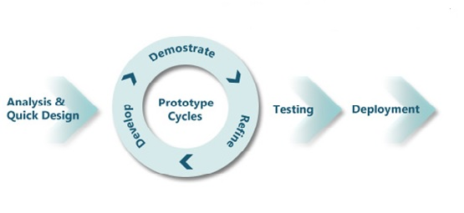

Figure : Rapid Application Development (RAD) Methodology

In analysis and quick design stage, the project title and it draft is discussed among team member and the proposal is submitted to the supervisor for approving the project. The analysis about the current system is analyzed and an interview session is carried out at the Jabatan Pendidikan Melaka (JPM) in order to gain more data about the proposed system’s flow. An Entity Relationship Diagram (ERD) of this system is also design in this stage.

Once the proposal (idea) is approved, prototype cycles begin. The task for each module is distributed for each team member and the development of each system module start. The stage of develop, demonstrate and refine keep recycling until the system module is in a satisfied and logic condition.

When all the system modules have done, integration part begins. This is the main and difficult part because the entire system module has to integrate together before testing. In this part, administrator module which consists of publisher admin, school admin and head teacher should be integrating together as this part is developed by two team members, Muhammad Suhaili Faizzi and Nadia binti Naim. While announcement module, student information module and registration module should combine because these modules are developed by other two team members, Cheok Li Li and Nazrul Hafizi.

After integrate all the modules, the testing on web based system and mobile application proceeds. The error that found in testing part needs to solve earlier before deploy the mobile application and web system.

## System Development Technique

The system development techniques that will use in this project is Structured Analysis and Design Technique (SADT). SADT is a diagrammatic notation designed specifically to help people describe and understand systems. It offers building blocks to represent entities and activities, and a variety of arrows to relate boxes. These boxes and arrows have an associated informal semantics. SADT can be used as a functional analysis tool of a given process, using successive levels of details. The SADT method not only allows one to define user needs for IT developments, which is often used in the industrial Information Systems, but also to explain and present an activity’s manufacturing processes and procedures.

In addition, SADT is focus on process which is the priority concern in this project as this project involve more than two users, we need to know the actual process of how these users inter-related with this system. In this approach, data flow diagram(s) will be designed for system architecture and entity relationship diagram (ERD) is designed for the system database. According to this technique, it gives the well-structured of database design which will easier us to handle/manage the whole database in this system. It is flexible and can change from time to time.

## Conclusion

In conclusion, this system is developed using RAD method to ensure a smoothness of our development project, completing the development on time and to prevent any unwanted occurrence.

# CHAPTER 3

## SYSTEM ANALYSIS

## Analysis of Current System

### Introduction

The current system for announcement from school and Jabatan Pendidikan Melaka (JPM) is they spread the news or important message through their official websites or spread through teachers, and teachers will pass the messages to parents. Furthermore, the current system records the student’s academic result on the school computer and the result will be printed for parent to check and sign. The printed result is delivered to parent manually (by hand). Besides that, disciplinary problems are recorded and send to parents by using postal mail letter, or parents are contacted by school over telephone to be informed on their children wrongdoing.

### Analysis of the Current Problem

The current system is inconvenience as parents need to wait the any update from school by watching news or being contacted by the school. They may miss the important news or phone call if they are busy working. In order to receive the update, they will have to trust their friends or neighbour, or even scroll over social network. This is an inefficient way to deliver messages to parents as the message might come from some unreliable source. Moreover, posting an important document such as a disciplinary complaint is not an effective way to do something as important. The education bureau and school hardly knows whether the parents have received the letter or not. The letter might not reach the parents after all. Usually, primary school or secondary school will hold Parent’s Day to discuss with parents on their children’s academic performance. Some parents might not be able to attend the Parent’s Day; hence they might be misinformed of the children academic development.

### Conclusion

With the existence of internet and smartphones, the current manual system should have been considered obsolete. Hence, the Parent Updater System is developed to ensure that Malaysia schooling system is implementing the most suitable practices made available by current technologies. The details of this system background will be discussed on next section (*section 3.2*).

## Analysis of Proposed System

### Background

The main functionality for Parent Updater System is that will be able to notify parents on any school announcement in a short time. With this feature, we need to make any announcement made in the Parent Updater System as a verified announcement from school or educational bureau. This is to ensure, parents can trust any announcement made via Parent Updater System. Next, parents will also be able to keep track of their children academic result and discipline record without going to school.

To deliver the target that this system will be able to notify parents on any announcement by the school, we will develop a mobile application for the end user. The justification for this action is because nowadays, almost every parents use smart phone. With the existence of a mobile application that support this action, announcement can be spread almost instantaneously; similar to how pager was years ago.

Announcement can only be made by school administrator and publisher admin only. This will tackle the second suggestion that announcements are verified. One school will only get one administrator account, and one publisher will get one administrator account. Parents will no longer feel dilemma on trusting any announcement whether they are correct information or false information. The suggestion for administrator support only is made available on web.

Any announcement made is only available for parents, to whom the announcement concern with their children only. This mean that only parents whom their children go to school at the school involving with the announcement only will be notified.

A school administrator can only make announcement involving their school, whereas an educational bureau can only make announcement involving their district area which they have power over. This ensures that administrator do not have authority over schools to which should not concern them.

The mobile application will also enable parents to check their children disciplinary record and academic results. This will indirectly tackle the second problem because parents will be able to see their children records anywhere through the mobile application.

### Functional Requirement

The following table shows the modules and their description.

|  |  |
| --- | --- |
| Modules | Description |
| Administrator Module | This module consist of three admins, which are head teacher, school admin and publisher admin. They have their own role in this module.  Head teacher – They insert student info like their name and IC number, and their parent’s information, as well as their academic result and discipline record.  Publisher admin – They create announcement which has been approved by approver and save the announcement to database. The announcement will send to announcement module.  School admin – They create announcement which has been approved by approver and save the announcement to database. The announcement will send to announcement module. |
| Registration Module | User need to register account in app before accessing the app. The IC number and contact number is needed to match those info with database which save from web system by head teacher. |
| Announcement Module | User able to view the announcement from their children school or JPM. This module includes the notification function which the registered account in this app will receive the notification that sends from administrator module. User also able to add the announcement to their calendar app to avoid forgotten. |
| Student Information Module | User able to view their children’s academic result and discipline record. |

Table : Functional Requirement of PUS

## Structure Chart of Proposed System

The following figure shows the structure chart of the proposed system:



Figure : PUS structure chart

## Work Breakdown

### Task Distribution

This section discusses the detail of work allocation and a Gantt chart is presented in order visualize the planning of activities to complete PUS on the given time.

This project is contributed by four UTeM students. The following diagram shows the position that is held by each group members:



Figure : PUS team work allocation

The following table shows the task distribution of each team member.

|  |  |
| --- | --- |
| Name | Task |
| Cheok Li Li | Registration module and Announcement module |
| Nadia Binti Naim | Administrator module |
| Muhammad Suhaili Faizzi Bin Abdul Shukor |
| Nazrul Hafizi Bin Nasarudin | Mobile app design and Student Information module |

Table : Task distribution

1. **Gantt chart**

The following diagram shows the project activities:

|  |  |  |  |  |  |  |  |  |  |  |  |  |  |  |  |  |
| --- | --- | --- | --- | --- | --- | --- | --- | --- | --- | --- | --- | --- | --- | --- | --- | --- |
| No | Phase | Activity | 1 | 2 | 3 | 4 | 5 | 6 | 7 | 8 | 9 | 10 | 11 | 12 | 13 | 14 |
| 1 | Planning | Discuss project title |  |  |  |  |  |  |  |  |  |  |  |  |  |  |
| 2 | Discuss project proposal |  |  |  |  |  |  |  |  |  |  |  |  |  |  |
| 3 | Writing project proposal |  |  |  |  |  |  |  |  |  |  |  |  |  |  |
| 4 | Submit project proposal |  |  |  |  |  |  |  |  |  |  |  |  |  |  |
| 5 | Analysis | Writing project progress report I   * Methodology * Analysis of current system * Analysis of proposed system |  |  |  |  |  |  |  |  |  |  |  |  |  |  |
| 6 | Design the initial screen (System Flow)  with their description |  |  |  |  |  |  |  |  |  |  |  |  |  |  |
| 7 | Review the initial screen with supervisor |  |  |  |  |  |  |  |  |  |  |  |  |  |  |
| 8 | Interview with potential users   * Re-design the screen if the screen not meet with the user requirement |  |  |  |  |  |  |  |  |  |  |  |  |  |  |
| 9 | Produce SRS (Optional) |  |  |  |  |  |  |  |  |  |  |  |  |  |  |
| 10 | Submit project progress report I |  |  |  |  |  |  |  |  |  |  |  |  |  |  |
| 11 | Design | Writing progress report II   * Database design * Module design * Implementation * Security Attributes |  |  |  |  |  |  |  |  |  |  |  |  |  |  |
| 12 | Writing test case |  |  |  |  |  |  |  |  |  |  |  |  |  |  |
| 13 | Review test case |  |  |  |  |  |  |  |  |  |  |  |  |  |  |
| 14 | Design the diagram   * Class diagram * Sequence diagram |  |  |  |  |  |  |  |  |  |  |  |  |  |  |
| 15 | Implementation | Submit progress report II |  |  |  |  |  |  |  |  |  |  |  |  |  |  |
| 16 | Write the code |  |  |  |  |  |  |  |  |  |  |  |  |  |  |
| 17 | Writing progress report III   * Poster preparation |  |  |  |  |  |  |  |  |  |  |  |  |  |  |
| 18 | Submit progress report III |  |  |  |  |  |  |  |  |  |  |  |  |  |  |
| 19 | Revision Final Report & Log Book |  |  |  |  |  |  |  |  |  |  |  |  |  |  |
| 20 |  | Presentation Day |  |  |  |  |  |  |  |  |  |  |  |  |  |  |
| 21 |  | Final Report and Log Book Submission |  |  |  |  |  |  |  |  |  |  |  |  |  |  |

Table : Gantt chart

## Conclusion

Based on the analysis of proposed system, the functional requirement stated is the main part in developing this software system. Each team member has their own task (for those main parts) in this project and we have to finish our module according to the Gantt chart in order to avoid late submission.

# CHAPTER 4

## SYSTEM DESIGN

## Introduction

This chapter will be discussed on the overall system design with more details. The description of each modules or design specification of all functions that have been developed is stated here. Interface of the design outputs and design of the database are explained detail under this chapter.

## System Architecture

Parent Updater System (PUS) has two system architectures, which are web system and mobile app. The subparagraphs show the data flow diagram of the modules of this system.

### Data Flow Diagram for PUS web based system

Context Diagram



Figure : Context Diagram for PUS web based system

Level 0 Diagram



Figure : Level 0 Diagram for PUS web based system

Level 1 Process 1 – Login



Figure : Login Process

Level 1 Process 2 – Manage announcement



Figure : Manage Announcement Process

Level 1 Process 3 – Manage student information



Figure : Manage Student Information Process

Level 1 Process 4 – Manage academic result



Figure : Manage Academic Result Process

Level 1 Process 5 – Manage discipline record



Figure : Manage Discipline Record Process

### Data Flow Diagram for PUS mobile application

Context Diagram



Figure : Context Diagram for PUS mobile application

Level 0 Diagram



Figure : Level 0 Diagram

Level 1 Process 1 – Login



Figure : Login Process

Level 1 Process 2, 3, 4 – View announcement, children academic result, discipline record



Figure : View announcement, children academic result and discipline record process

## Database Design

### Entity Relationship Diagram (ERD)



Figure : Entity Relationship Diagram (ERD)

### Data Dictionary

This project ERD consists of 14 entities. The following shows the data dictionary for each entity.

1. announcement

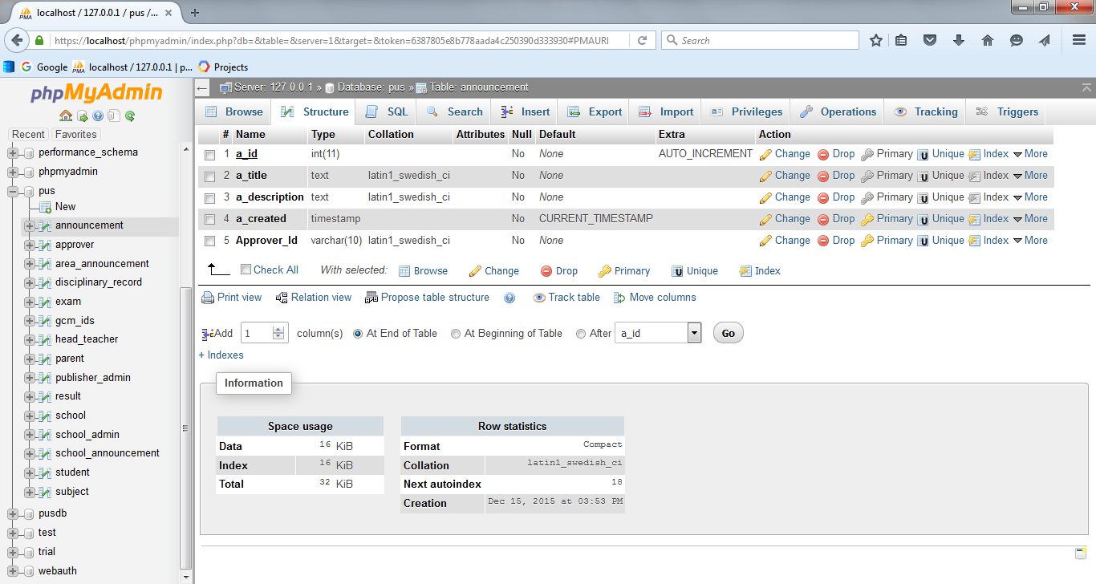

Table : announcement table

1. approver

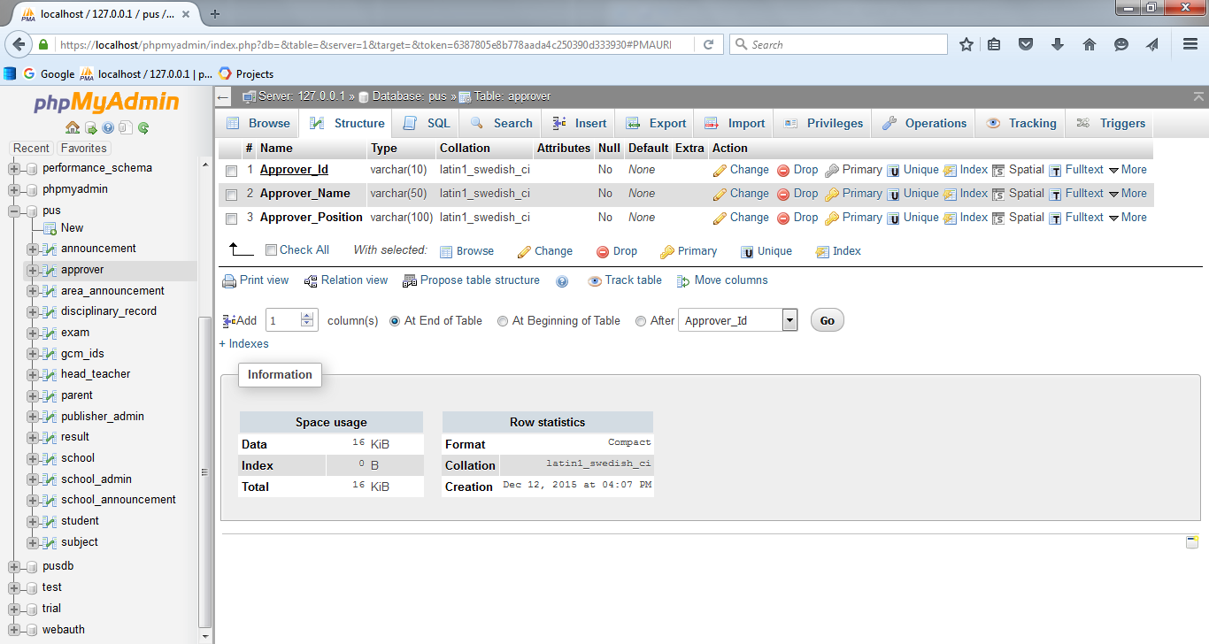

Table : approver table

1. area_announcement

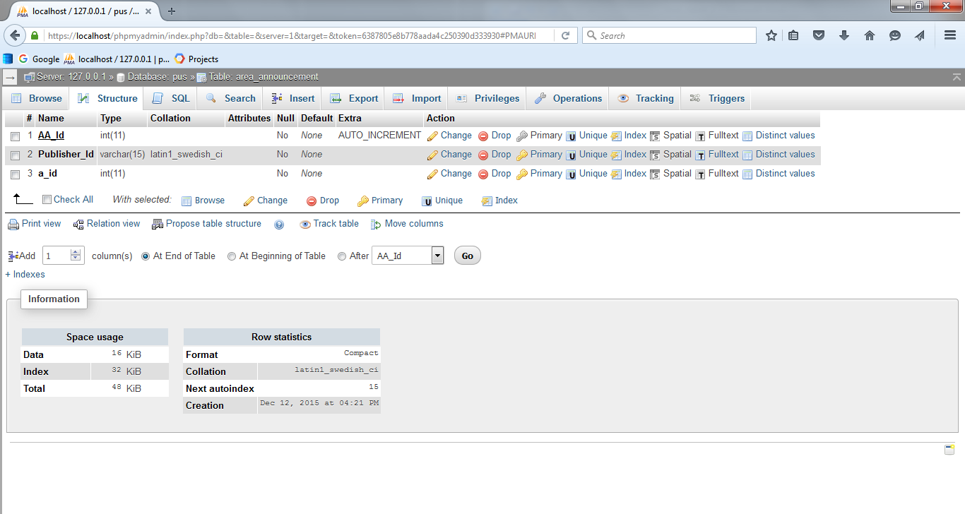

Table : area_announcement table

1. disciplinary_record

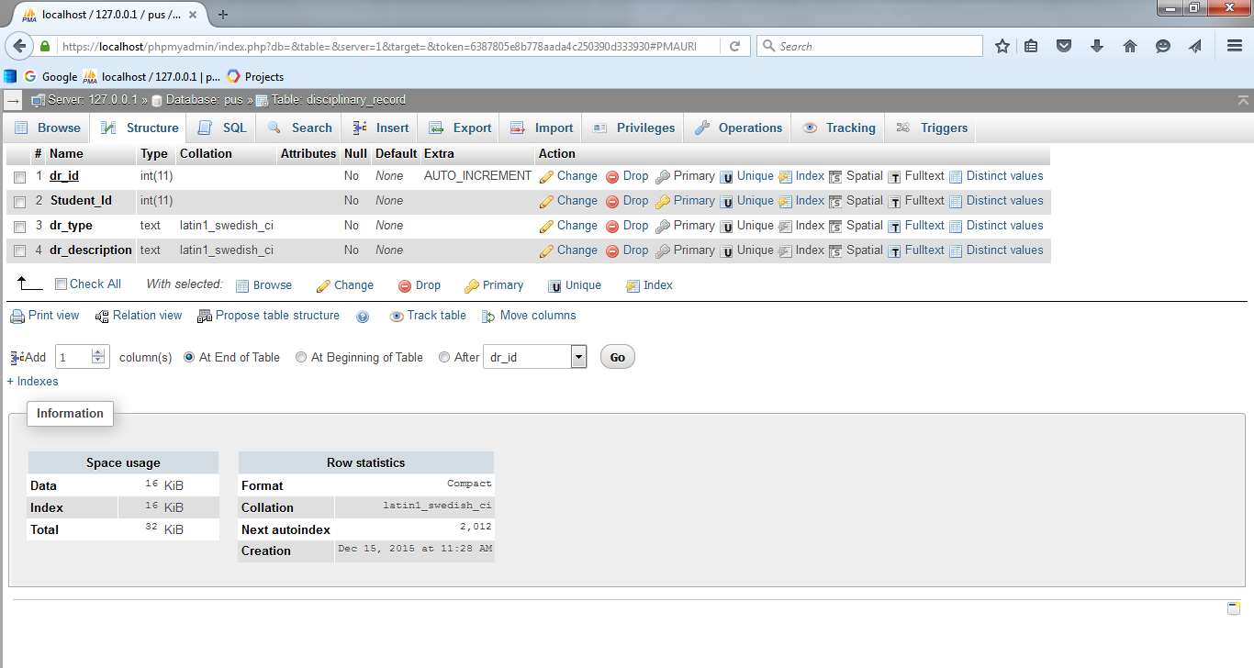

Table : disciplinary_record

1. exam

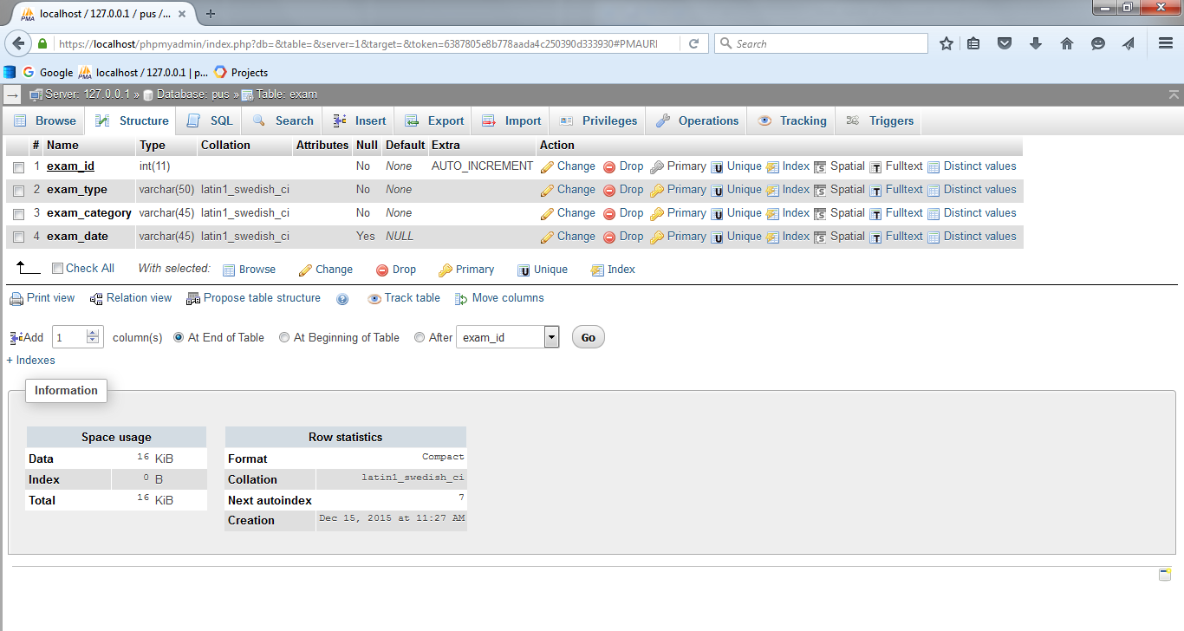

Table : exam table

1. head_teacher

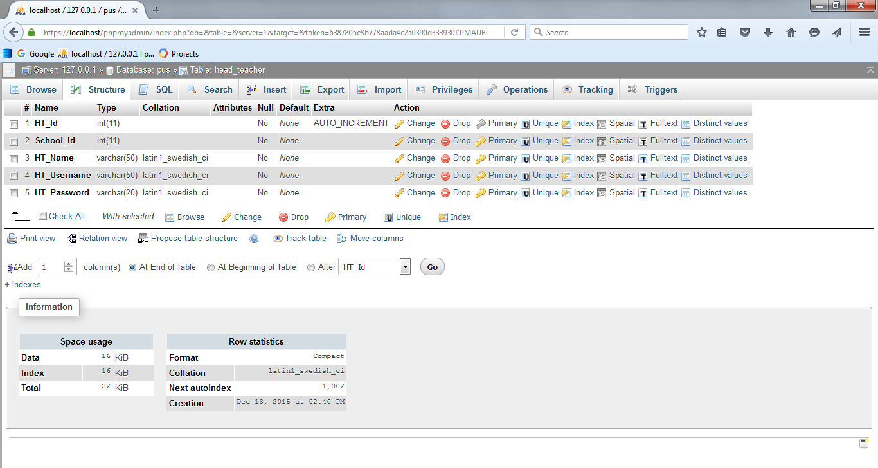

Table : head_teacher table

1. parent

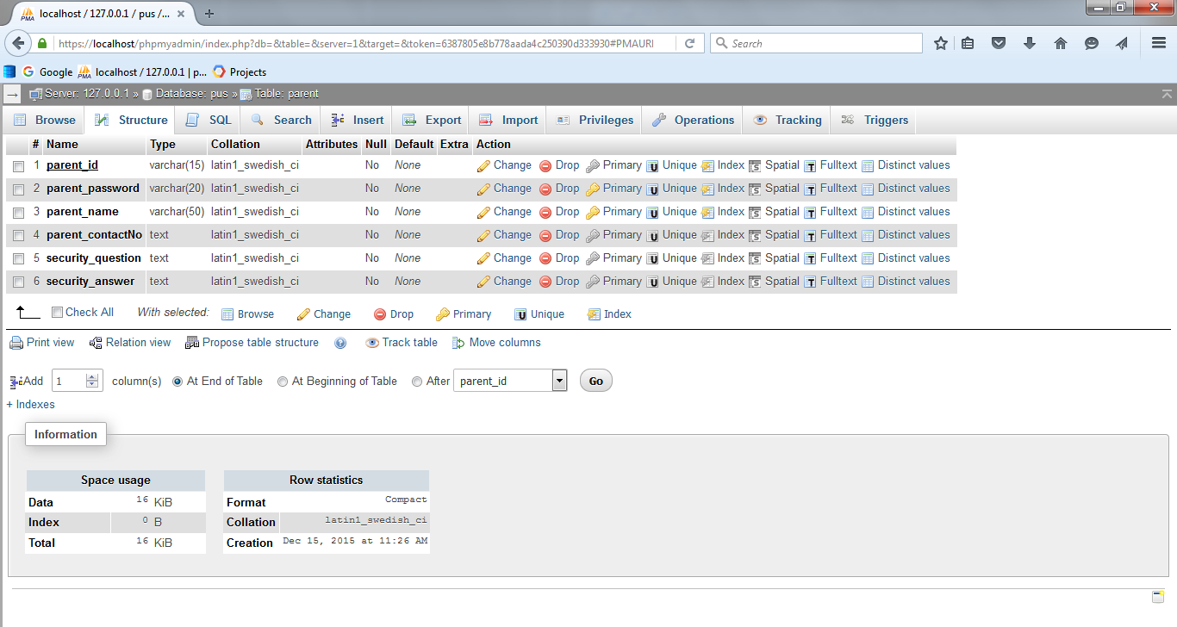

Table : parent table

1. publisher_admin

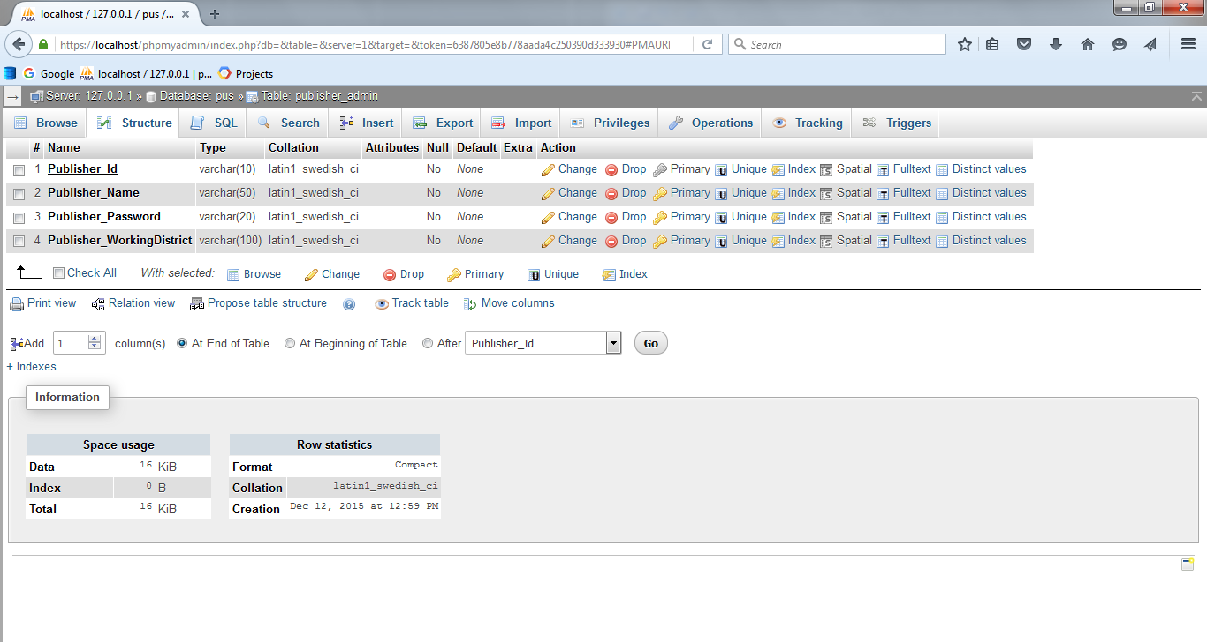

Table : publisher_admin table

1. result

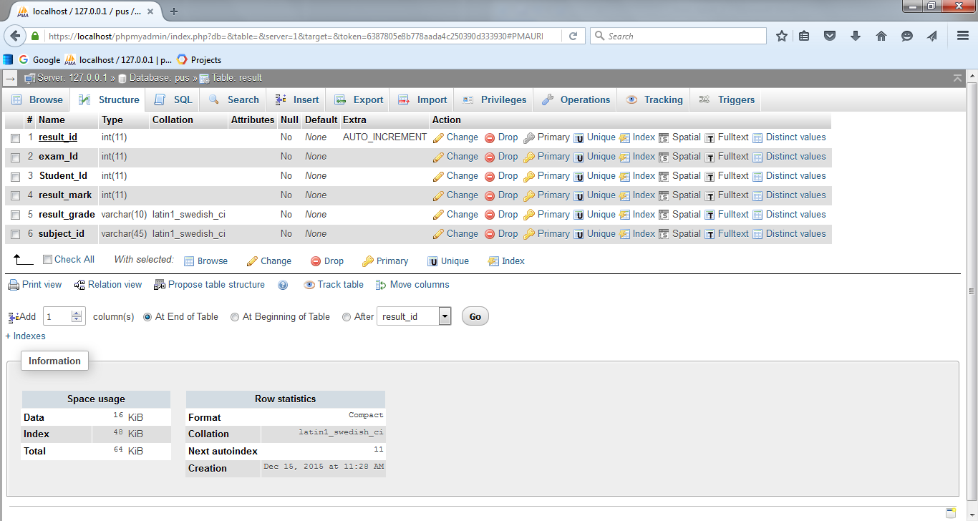

Table : result table

1. school

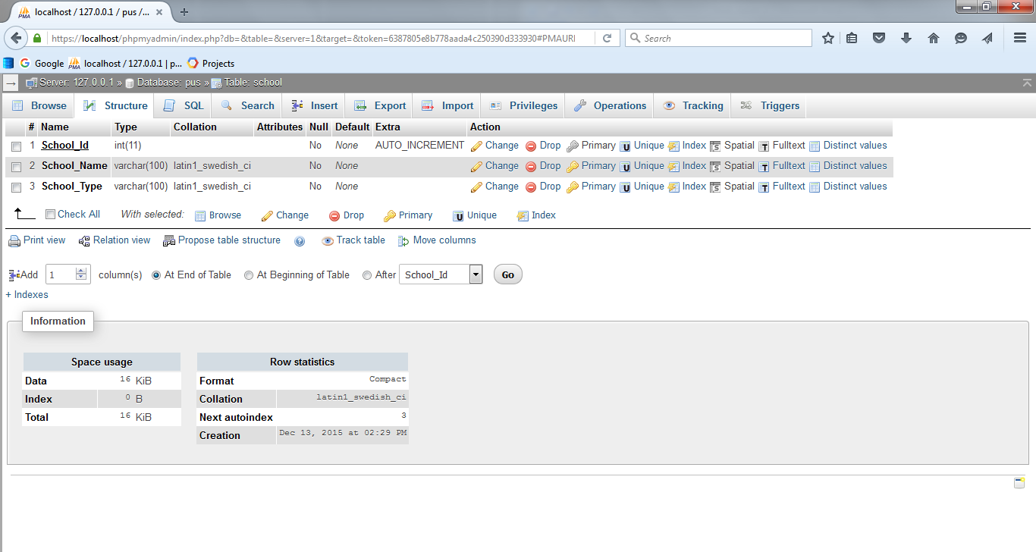

Table : school table

1. school_admin

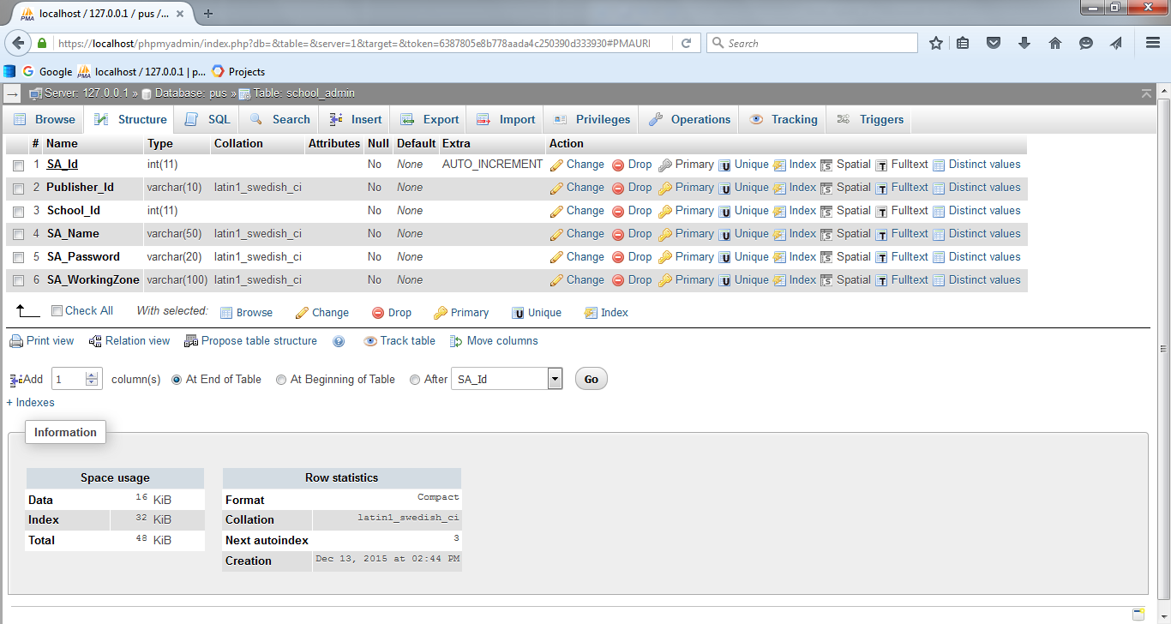

Table : school_admin table

1. school_announcement

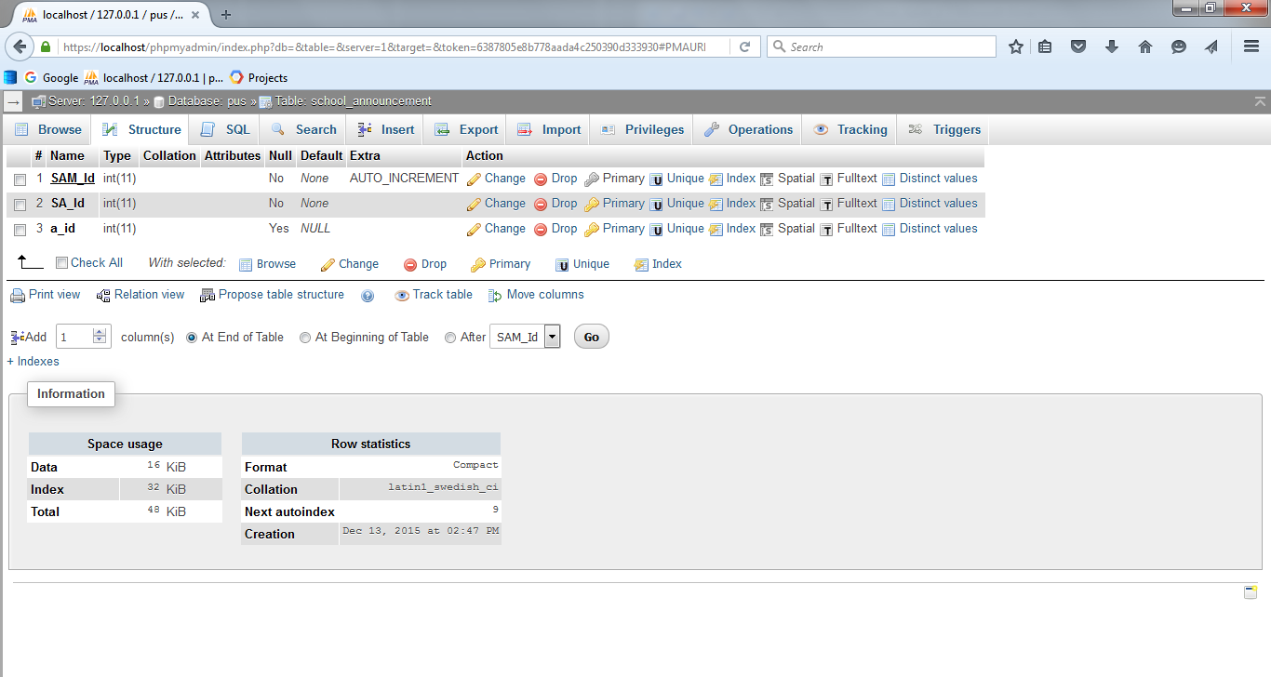

Table : school_announcement table

1. student

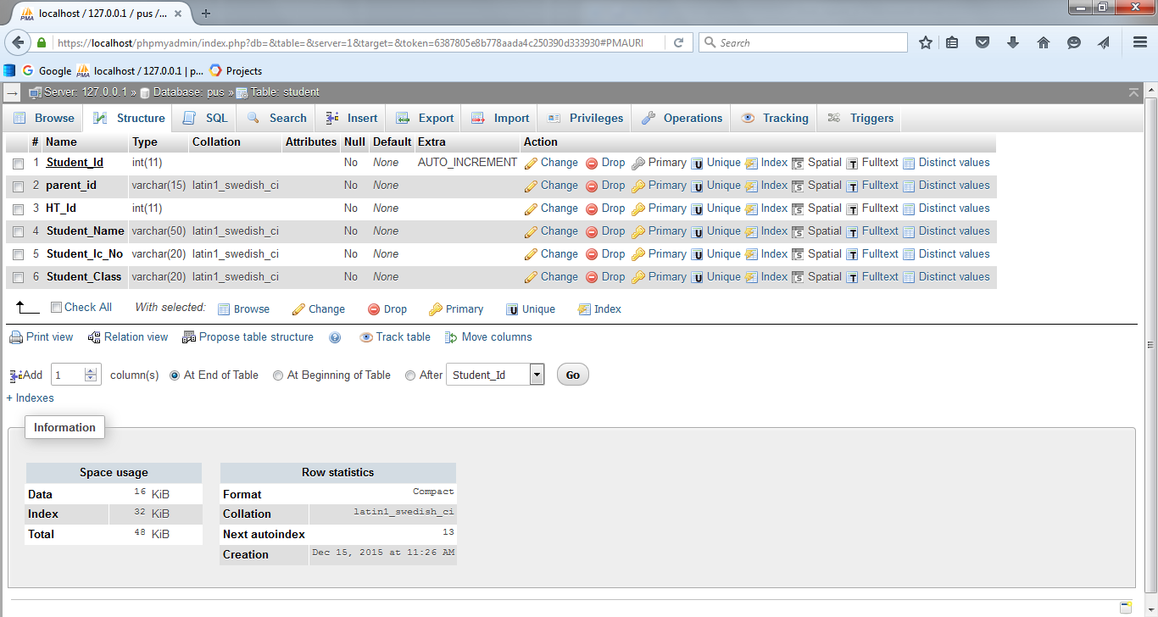

Table : student table

1. subject

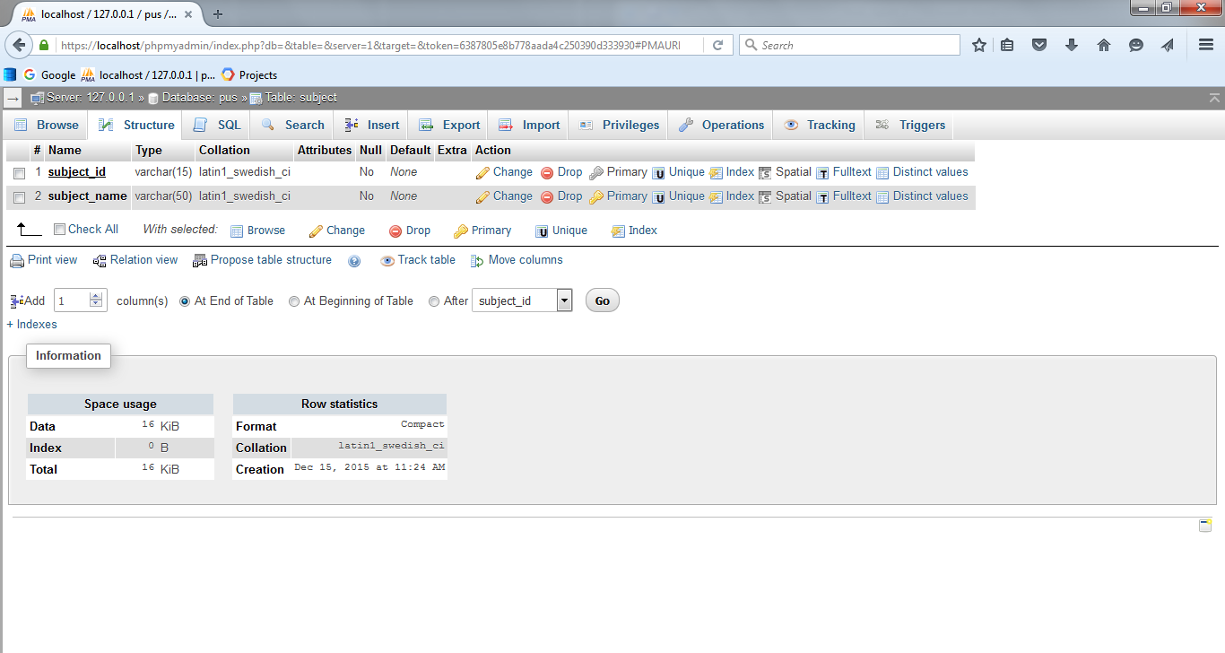

Table : subject table

## Module Integration and Interface Design

### For PUS web based system design:

### Teacher Login Screen

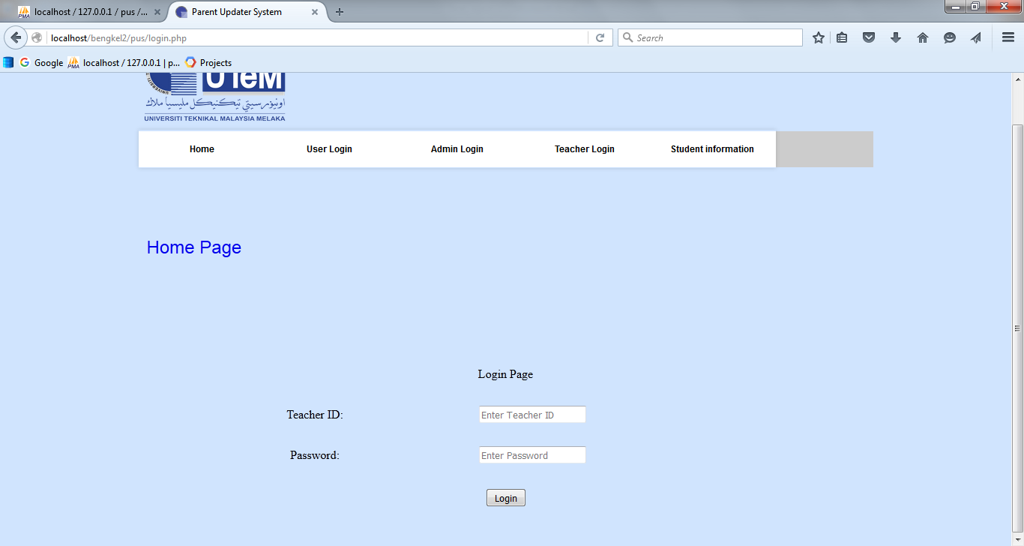

Figure : Teacher Login Screen

### Student Information Screen

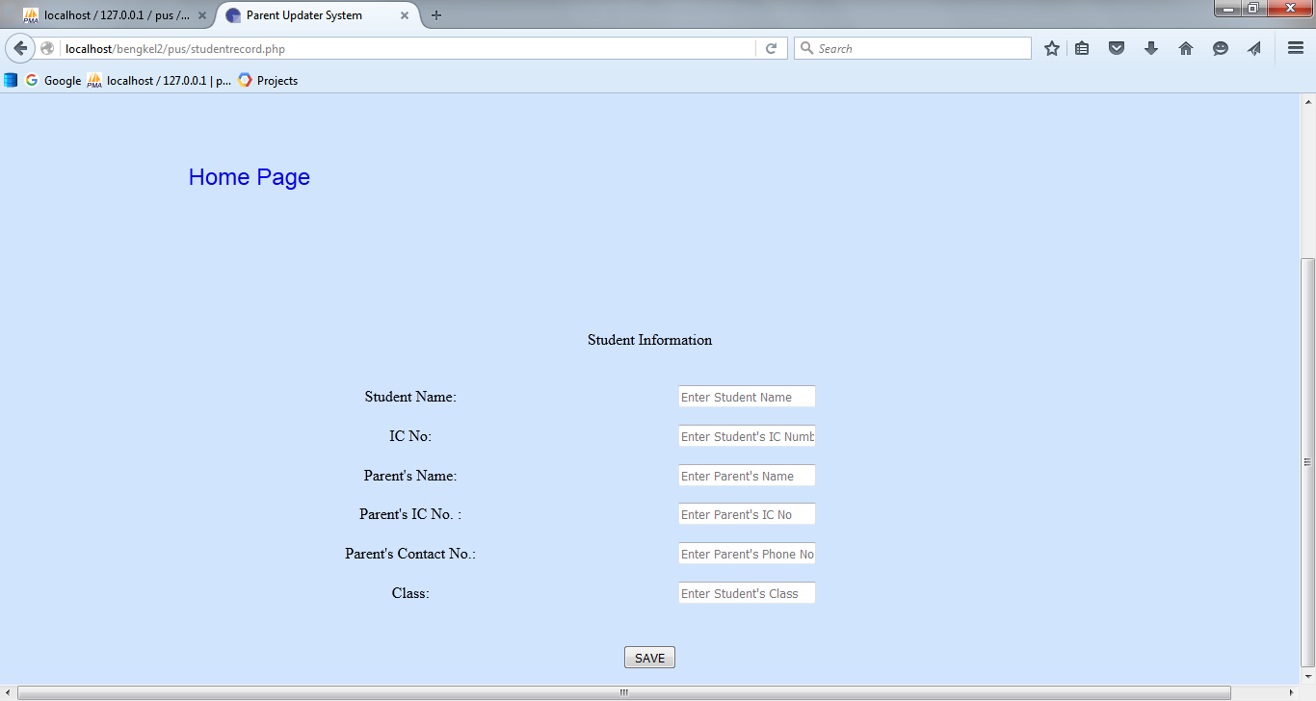

Figure : Student Information Screen

### Discipline Record Screen

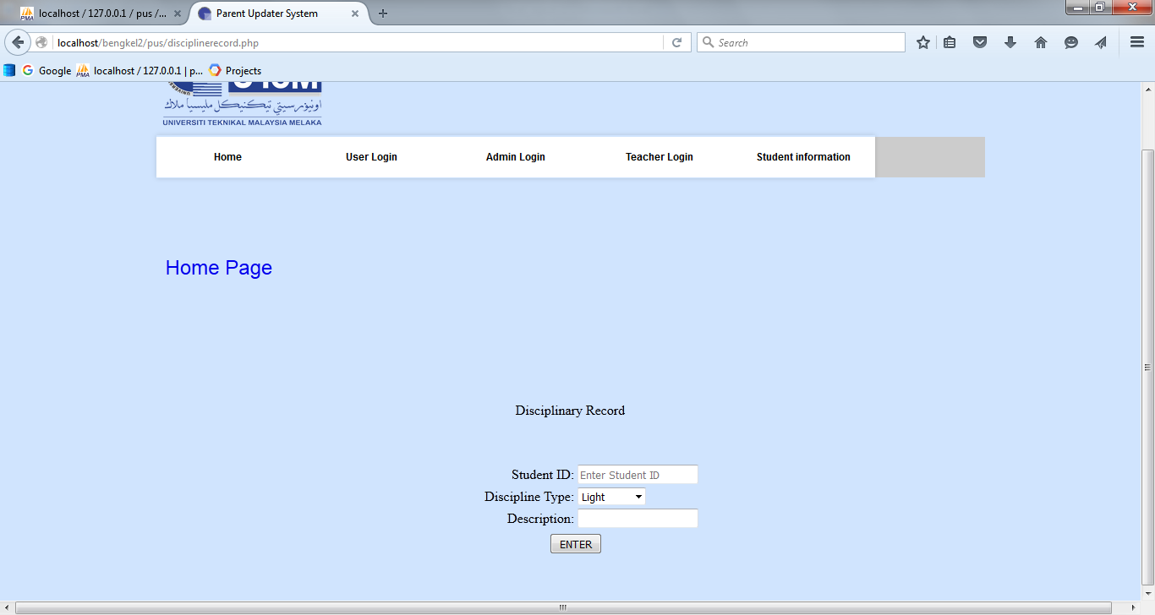

Figure : Discipline Record Screen

### Academic Result Screen

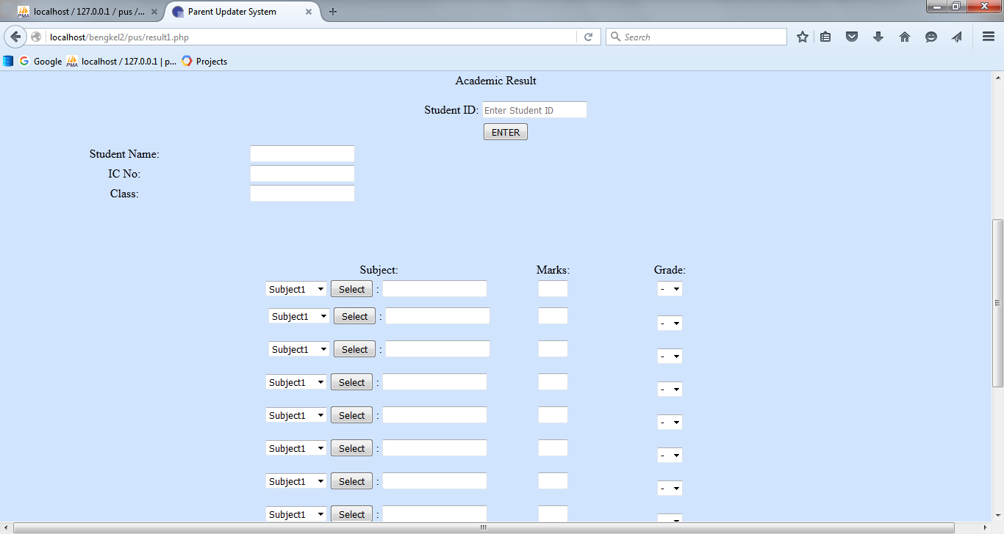

Figure : Academic Result Screen

### Publisher and School Admin Login Screen

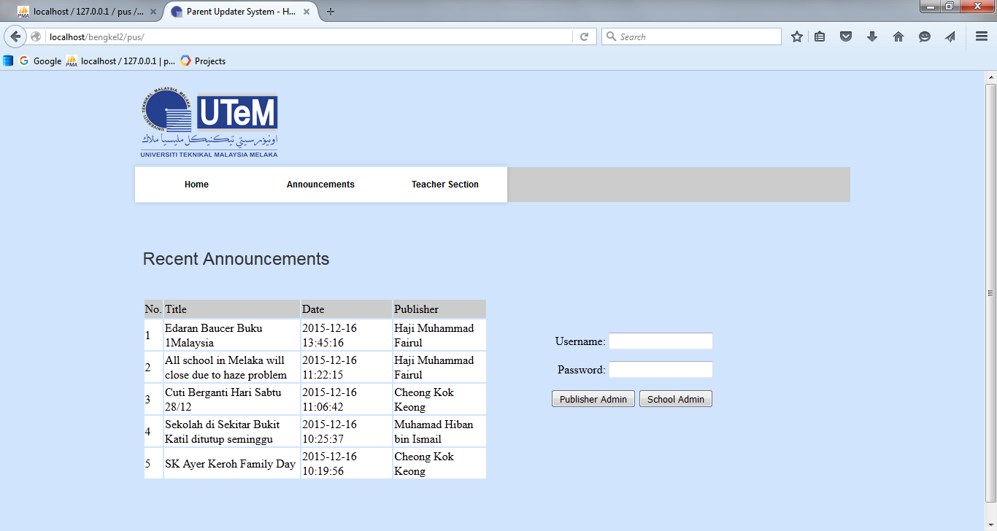

Figure : Publisher and School Admin Login Screen

### Create Announcement (Publisher and School Admin)

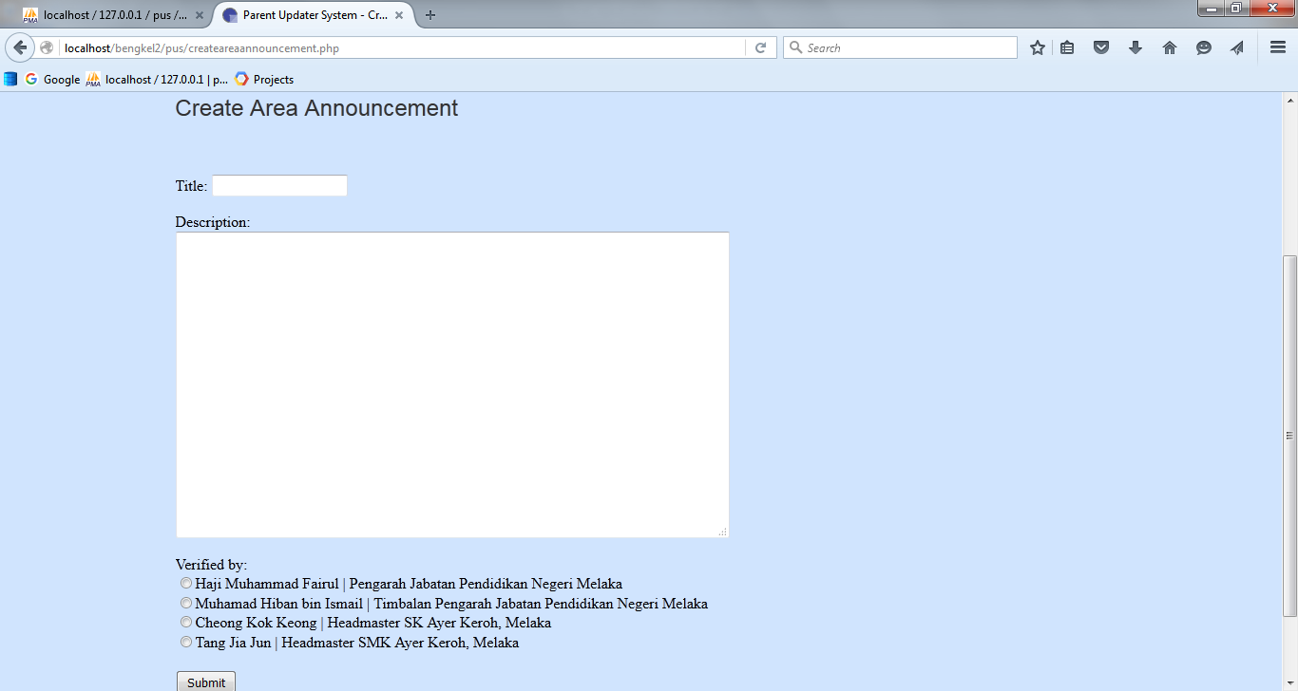

Figure : Create Announcement (Publisher and School Admin)

### View Announcement list (Publisher Admin)

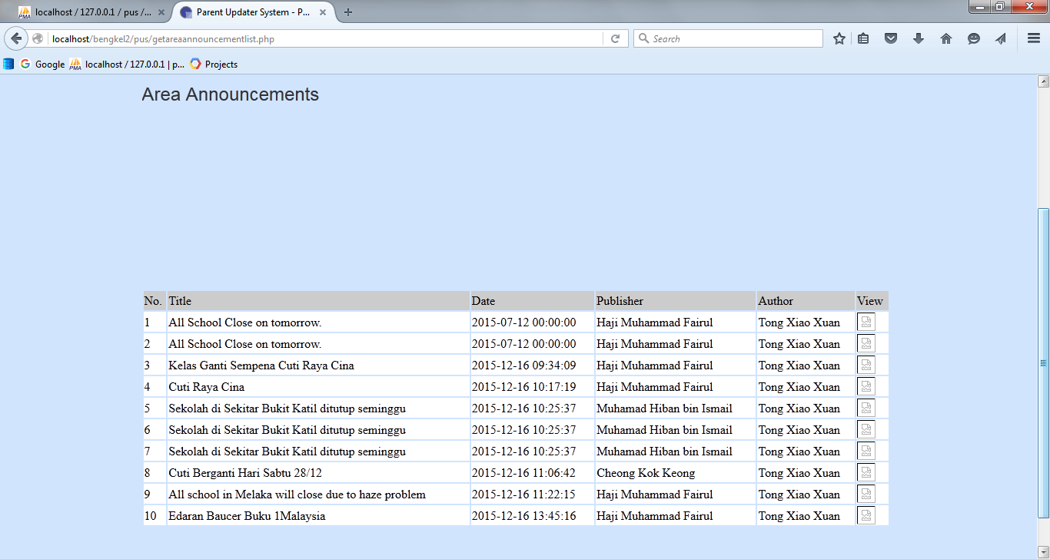

Figure : View Announcement list (Publisher Admin)

### View Announcement (School Admin)

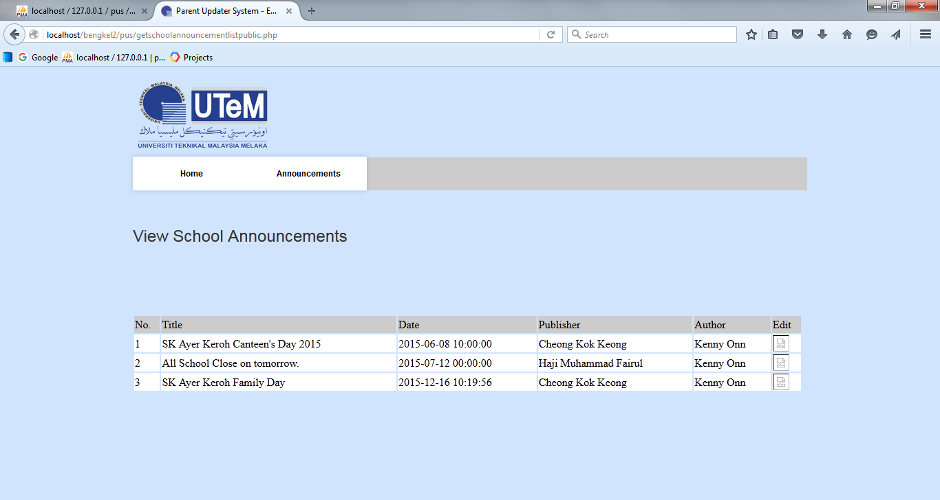

Figure : View Announcement (School Admin)

### The formal letter for announcement

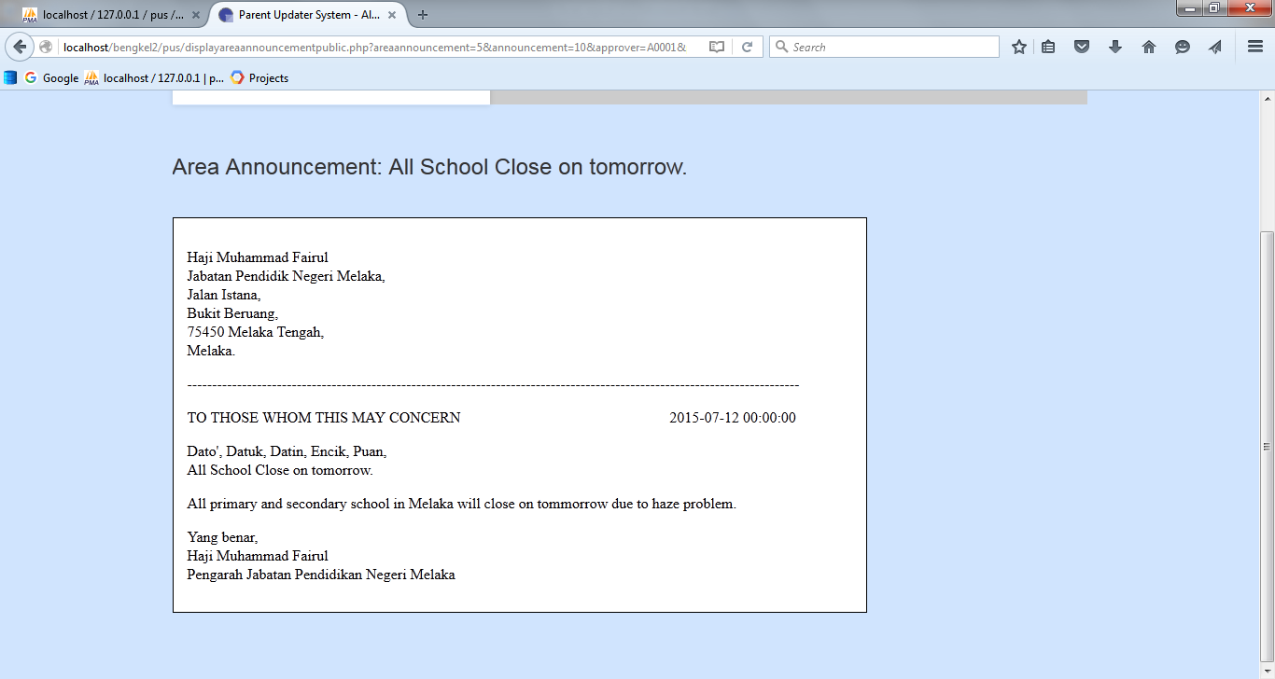

Figure : Formal letter for announcement

### For PUS mobile application design:

### Launch Screen

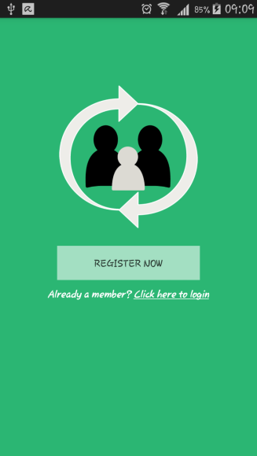

Figure : Launch Screen

### Registration Screen

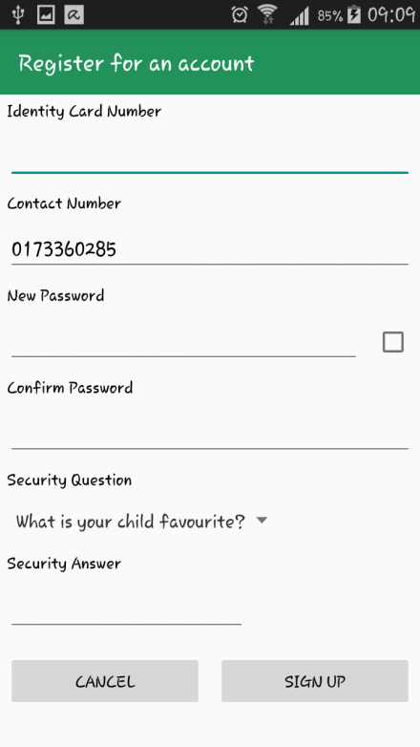

Figure : Registration Screen

### Login Screen

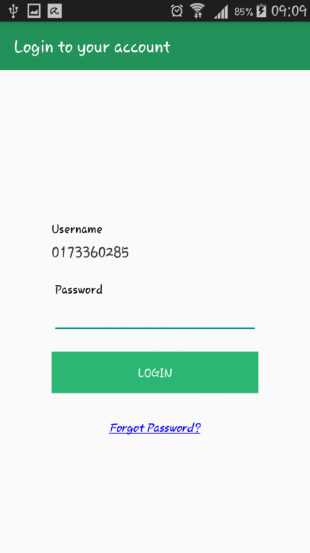

Figure : Login Screen

### Confirmation message for Cancel

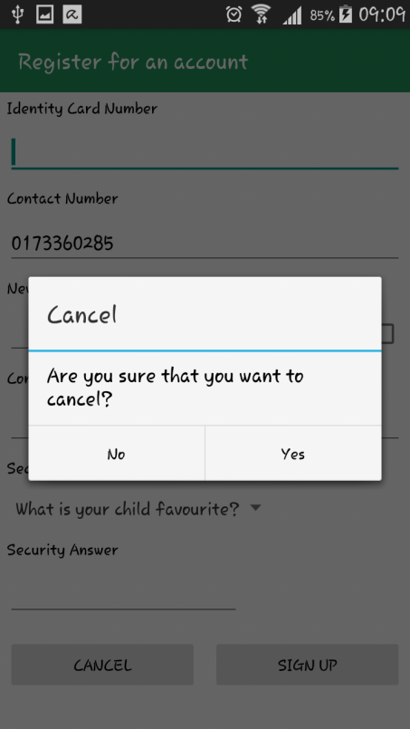

Figure : Confirmation message for Cancel

### Security Question and Answer Dialog

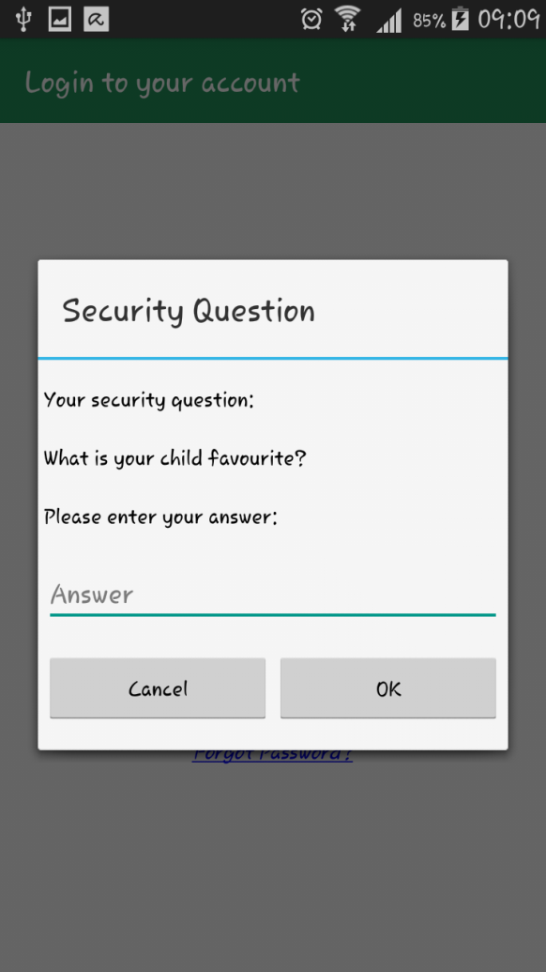

Figure : Security Question and Answer Dialog

### Reset Password Dialog

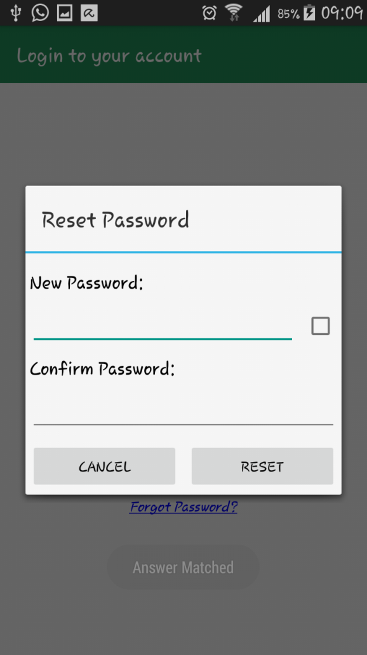

Figure : Reset Password Dialog

### Left Drawer Screen

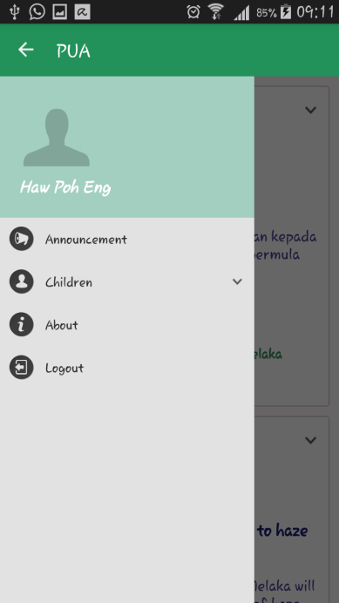

Figure : Left drawer Screen

### User Profile Screen

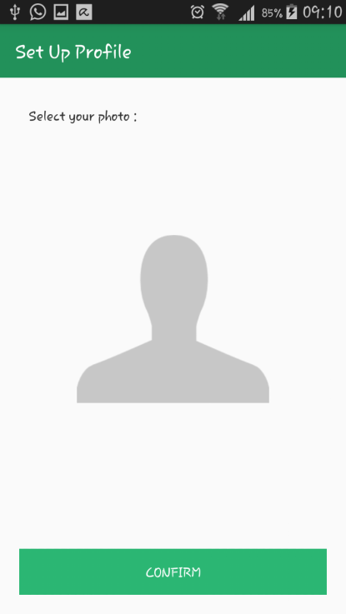

Figure : User Profile Screen

### Announcement Screen

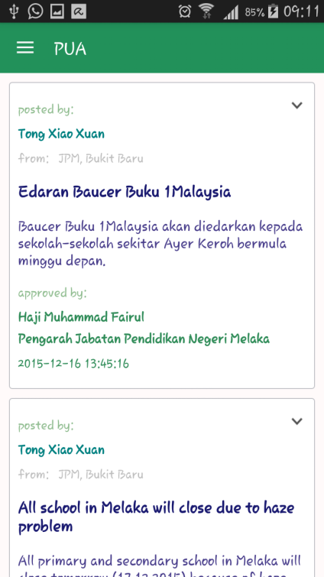

Figure : Announcement Screen

### Children Layout Screen

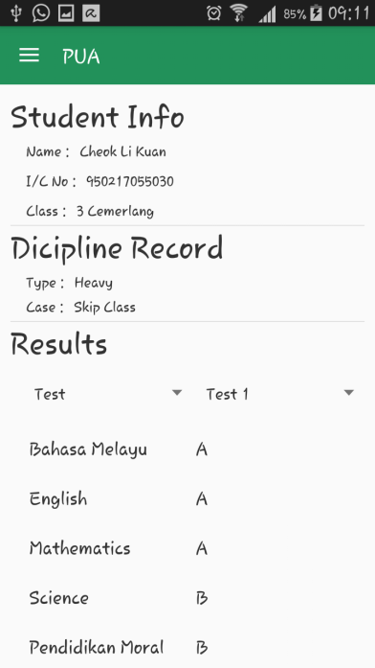

Figure : Children Layout Screen

### About Screen

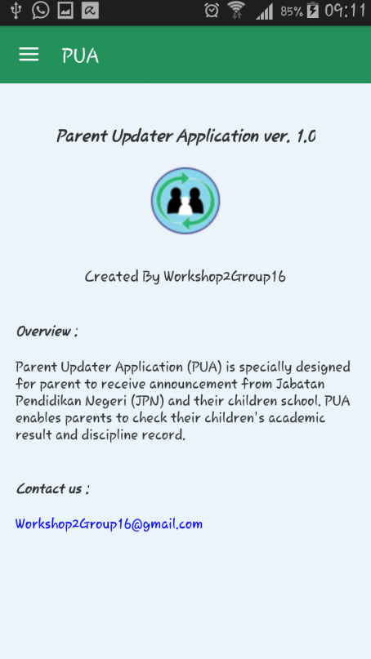

Figure : About Screen

### Logout Dialog

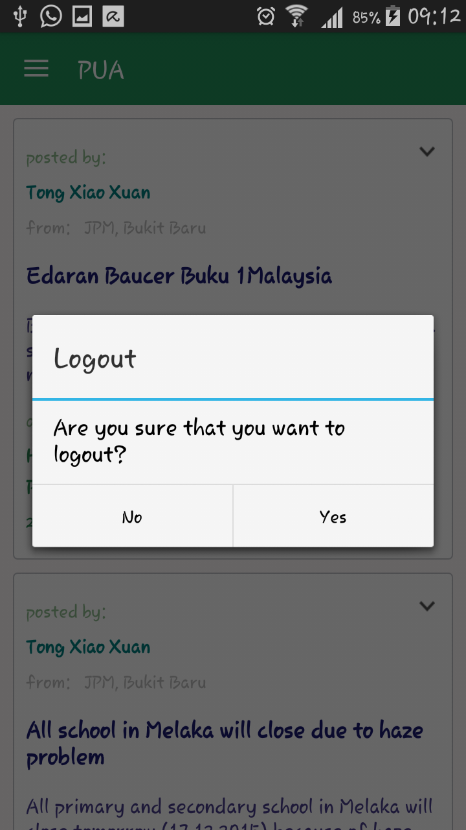

Figure : Logout Dialog

## System Design

System design is the process of defining and developing a system to meet the needs of specific users. DFD is used in this system as this project is focus on the process of spreading announcement from JPM or school to parent. ERD is more understand for database implementation as it is flexible and can changes if any encountered any error.

## Conclusion

As a conclusion, system design for mobile application is focused the most because it is used and displayed to the user. The app is designed in a simple and easy understand layout to avoid making confuse about the screen layout for who used this mobile application.

# CHAPTER 5

## SYSTEM IMPLEMENTATION

## Introduction

This chapter is discussed about the implementation of the required software system before development stage begins. The purpose of this stage is to prepare the required software system which available in the specific official websites and most of this required software system is provided in free version. In this stage, team member is carried out the execution or practice of plan, method and design for the system that has been build. The execution includes the installation, configuration, running, testing, and making necessary changes of the system.

## System Development Environment

Parent Updater System (PUS) will develop by using the following software system.

### Eclipse

Eclipse Java Luna with ADT plugin is used to develop the PUS android system (written in Java programming language) that will be installed in android supported smartphones. The details of this software system are described in the following paragraphs.

Eclipse is an integrated development environment (IDE) in computer programming. It is written mostly in Java and its primary use is for developing Java applications, but it can also use to develop applications in other programming languages. Android Development Tools (ADT) is a Google-provided plugin for the Eclipse IDE that is designed to provide an integrated environment in which to build Android applications. ADT extends the capabilities of Eclipse to let developers set up new Android projects, create an application UI, add packages based on the Android Framework API, debug their applications using the Android SDK tools, and export signed (or unsigned) .apk files in order to distribute their applications. It is free download.

### XAMPP Server version 3.2.1

XAMPP Server version 3.2.1 is used to store the PUS database in local host. The details of this software system are described in the following paragraphs.

XAMPP Server version 3.2.1 used is automatically installed with Apache, PHP, MySQL database, phpMyAdmin and other packages. XAMPP is a free and open source cross-platform web server solution stack package developed by Apache Friends, consisting mainly of the Apache HTTP Server, MySQL database, and interpreters for scripts written in the PHP and Perl programming languages. Some package provided like phpMyAdmin in XAMPP is required to build this project database, which the database is stored in localhost in order to avoid the database lose in unexpected condition.

### Adobe DreamWeaver CS5

Adobe DreamWeaver CS6 will use to develop the PUS web based system. The details of this software system are described in the following paragraphs.

Adobe DreamWeaver is a closed-source web development tool that is originally created by Macromedia. The provided tools by the Dreamweaver contains solution and subsequent version that more compliant with W3C standards. Adobe Dreamweaver CS5 supports scripting languages and frameworks including ASP,Scriplet and PHP. It is a web design and development application that provides visual with standard features as well as more sophisticated features such as real-time syntax checking and code introspection for generating code hints to assist the user to write codes and reduced syntax error and misspelling. Adobe Dreamweaver also facilitates with rapid layout design and code generation as it allow users to quickly create and manipulate the layout.

### Windows 7

This project use operating system Windows 7 (64 bit). Service pack 1 used to deploy the project and for the Xampp Server, Eclipse and Adobe DreamWeaver installation.

## System Configuration Management

The purpose to have software configuration management is to test the whole system and defines the error of misconfiguration, error in codes of both software and hardware. Software configuration for each of the required software system should be managing well before develops this project in order to prevent the some feature error. This is the important stage for installing a proper software system.

### Installation of Eclipse Java Luna with ADT plugin

1. Download the Eclipse SDK installer from <http://developer.android.com/tools/sdk/eclipse-adt.html> .
2. Run the eclipse.exe after downloaded.
3. The eclipse is ready to use.

### Installation of Java TM Platform SE Binary

1. Download the Java JDK from <http://www.oracle.com/technetwork/java/javase/downloads/index.html> .
2. Run the .exe after downloaded.

### Installation of Xampp Server

1. Download the XAMPP Server from http://www.apachefriends.org /downloads.html
2. Run the installer after downloaded and a setup as shown in figure below will display.

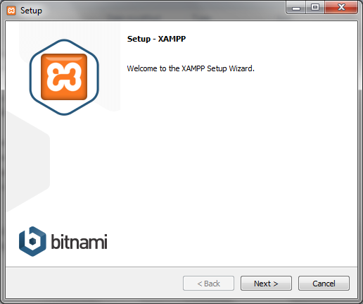

Figure : Setup – XAMPP

1. Accept the term and condition and the program will install automatically.
2. Run the phpMyAdmin in a XAMPP Server icon that appeared on the window taskbar and login with root as username and blank the password to obtain the page as shown in figure below and start to create the database of project.

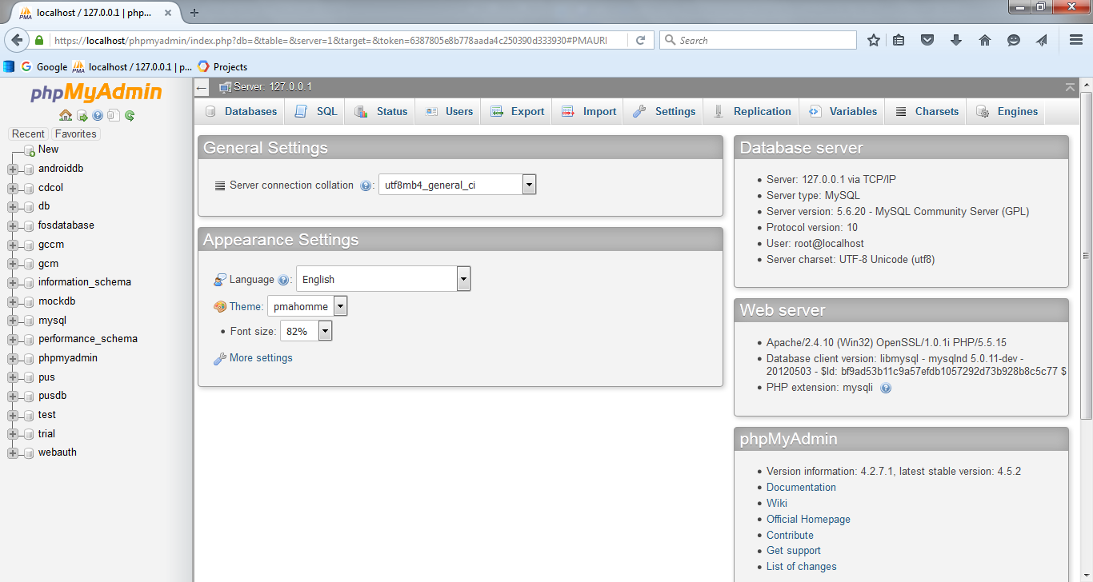

Figure : phpMyAdmin

### Installation of Adobe DreamWeaver CS6

1. Download or purchase the Adobe Dreamweaver CS5 from the Macromedia/Adobe Official web site.
2. Run the installer and enter serial number in the beginning of the installation screen as shown.
3. 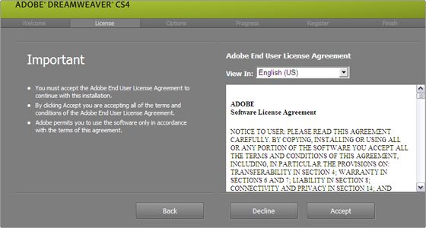

Figure : Installation setup of Adobe DreamWeaver

1. Accept and follow the instructions to finish installation of Adobe Dreamweaver CS5.

## Security Characteristics

### Availability

As for availability features, the system ensure the data to be available from database to be retrieved and display without error or data lost and data dislocating. The user will available to retrieve the desired information. This security characteristic can be found on Announcement and Student Information modules of this project which the data is being show in android from database.

### Authentication

The authentication part in this system is login. Only authorized users are allowed to access. With correct match of username and password, the authorized user can access the system and use it. While unauthorized user may need to register as a system’s user and then only can view the specific information. This is needed to prevent from unauthorized user to alter the data. Confidentiality, integrity and availability are emphasized in this system. This security characteristic is found in Administrator modules of this project.

### Integrity

This system concerns about data integrity. The data values, must be handle by authorized individual only. The data also must be protected from any damage or being altered by unauthorized user or any method used such as hacking or outside forces.

### Confidentiality

This system only allows the authorized user to access and view the information.

## Conclusion

This chapter concludes that the implementation of the software system is a very important process as it involves in getting the new system to operate properly in its environment including installation, configuration, testing and making necessary changes to the system. The system testing has to carry out carefully in order to ensure that the implemented system is created in the right and successful way.

Parent Updater System (PUS) can be access through both mobile app and website, but mobile app is only for user (parent) and website is for administrator only such as publisher admin, school admin and head teacher. This system is fully developed by PHP, HTML, MySQL, JAVA and Eclipse. Other than that, the system undergoes several securities by the programmer like asking a security question to the user who has forgot their login password. This function makes sure that the user account in mobile phone is not easily hacked by someone who is an unauthorized user for this system.

# CHAPTER 6

## SYSTEM TESTING

## Testing Model

System testing of software or hardware is testing conducted on a complete, integrated system to evaluate the system's compliance with its specified requirements. We have used Black-box testing methods to test up our web system and android application:

1. Black-box Testing

Black-box testing is a method of software testing that examines the functionality of an application without peering into its internal structures or workings. This method of test can be applied to virtually every level of software testing: unit, integration, system and acceptance. It typically comprises most if not all higher level testing, but can also dominate unit testing as well.

1. White-box Testing/ Structural Testing

This testing tests internal structures or workings of a program, as opposed to the functionality exposed to the end-user. In an internal perspective of the system, as well as programming skills, are used to design test cases. The tester chooses inputs to exercise paths through the code and determine the appropriate outputs. Though this method of test design can uncover many errors or problems, it might not detect unimplemented parts of the specification or missing requirements. Techniques used in white-box testing include API testing, code, fault injection, mutation testing methods and static testing methods.

## Test Result Analysis

### Test Case 1: User Registration (User Info)

|  |  |  |
| --- | --- | --- |
| Test Case ID | TC_01 | |
| Functional requirement | Register | |
| Test requirement | “Validate that user can insert an entry in the column ‘Identity Card Number’, ‘New Password’, ‘Confirm Password’ and fill the ‘Security Answer’ | |
| Purpose | To test whether user can insert an entry in the column ‘Identity Card Number’, ‘New Password’, ‘Confirm Password’ and fill the ‘Security Answer’ | |
| Pre-condition | The application is installed | |
| Test data | Identity Card Number = {valid IC Number, invalid IC Number, empty}  Password = {valid password, invalid password, empty}  Security Answer = { any answer, empty} | |
| Steps | 1. Open the system  2. Click on button “Register Now”  3. User enter the Identity Card Number  4. User enter password  5. User enter the confirm password  6. User enter Security Answer | |
| Expected result | Pass | User can enter successfully enter the column |
| Fail | User cannot fill the column |
| Notes | Error maybe due to no internet connection | |
| Actual Result (Pass/Fail) | Pass | |

Table 18: User Registration Test 1

### Test Case 1: User Registration (Register button)

|  |  |  |
| --- | --- | --- |
| Test Case ID | TC_02 | |
| Functional requirement | Register | |
| Test requirement | “Validate that user can click the register button” | |
| Purpose | To test the register button | |
| Pre-condition | User must fill the registration form | |
| Test data | Click “Sign Up” button | |
| Steps | 1. Open the system  2. Click on button “Register Now”  3. User enter the Identity Card Number  4. User enter password  5. User enter the confirm password  6. User enter Security Answer  7. User click the “Sign Up” button | |
| Expected result | Pass | User can enter to the system |
| Fail | User cannot enter the system |
| Notes | Error maybe due to no internet connection | |
| Actual Result (Pass/Fail) | Pass | |

Table : User Registration Test 2

### Test Case 3: User Login (Login Info)

|  |  |  |
| --- | --- | --- |
| Test Case ID | TC_03 | |
| Functional requirement | Login | |
| Test requirement | “Validate that user can insert entry in the column password ” | |
| Purpose | To test whether user can insert an entry in the column password | |
| Pre-condition | * The application is installed * User must registered for this system | |
| Test data | password = {valid password, invalid password , empty} | |
| Steps | 1. Open System  2. Click the link “Click here to login”  3. Enter user password | |
| Expected result | Pass | User can enter the column password. |
| Fail | User cannot enter the column password. |
| Notes | Error maybe due to no internet connection | |
| Actual Result (Pass/Fail) | Pass | |

Table : User Login Test 1

### Test Case 4: User Login (Login button)

|  |  |  |
| --- | --- | --- |
| Test Case ID | TC_04 | |
| Functional requirement | Login | |
| Test requirement | “Validate that you can click the Login button ” | |
| Purpose | To test whether user can click Login button | |
| Pre-condition | * The application is installed * After user register for this system. * After user enter the password. | |
| Test data | Click Login button | |
| Steps | 1. Open System  2. Click the link “Click here to login”  3. Enter user password  4. User click Login Button | |
| Expected result | Pass | User can go to homepage. |
| Fail | User cannot go to the homepage. |
| Notes | Error maybe due to no internet connection | |
| Actual Result (Pass/Fail) | Pass | |

Table : User Login Test 2

### Test Case 5: Admin Login

|  |  |  |
| --- | --- | --- |
| Test Case ID | TC_05 | |
| Functional requirement | Admin Login | |
| Test requirement | “Validate that admin can login to the system ” | |
| Purpose | To test whether admin can login to the system | |
| Pre-condition | * After admin registered to the system | |
| Test data | Staff ID: {valid Staff ID, invalid Staff ID, empty}  Password : {valid password, invalid password, empty} | |
| Steps | 1. Open homepage  2. Enter Staff ID  3. Enter admin password  4. Click Login Button | |
| Expected result | Pass | Admin can go to next page. |
| Fail | Admin cannot go to the next page. |
| Notes | Error maybe due to no internet connection | |
| Actual Result (Pass/Fail) | Pass | |

Table : Admin Login Test

### Test Case 6: Admin Add Announcement

|  |  |  |
| --- | --- | --- |
| Test Case ID | TC_06 | |
| Functional requirement | Add Announcement | |
| Test requirement | “Validate that admin can add announcement to the system ” | |
| Purpose | To test whether admin can add announcement to the system | |
| Pre-condition | * Admin must login | |
| Test data | Tittle = {any title of announcement}  Description = {describe a little bit more about the title} | |
| Steps | 1. Click “Create Area Announcement”  2. Fill title column  3. Fill the description column  4. Mark in the radio button of the publisher of announcement | |
| Expected result | Pass | Admin can add new announcement. |
| Fail | Admin cannot add any announcement. |
| Notes | Error maybe due to no internet connection | |
| Actual Result (Pass/Fail) | Pass | |

Table : Admin Add Announcement Test

### Test Case 7: Admin Add Student Information

|  |  |  |
| --- | --- | --- |
| Test Case ID | TC_07 | |
| Functional requirement | Add Student Information | |
| Test requirement | “Validate that admin can add student information to the system ” | |
| Purpose | To test whether admin can add student information to the system | |
| Pre-condition | * Admin must login to the system | |
| Test data | Student Name = {any name, empty}  IC No = {student IC No, empty}  Parent’s Name = {any name, empty}  Parent’s IC No = {parent IC No, empty}  Parent’s Contact No = {any contact No, empty}  Class = {any class, empty} | |
| Steps | 1. Click “Student Information” button  2. Fill the entire column.  3. Click ‘SAVE’ button | |
| Expected result | Pass | Admin can add new student information. |
| Fail | Admin cannot add any new student information  . |
| Notes | Error maybe due to no internet connection | |
| Actual Result (Pass/Fail) | Pass | |

Table : Admin Add Student Info Test

### Test Case 8: Admin Add Student Result

|  |  |  |
| --- | --- | --- |
| Test Case ID | TC_08 | |
| Functional requirement | Add Student Result | |
| Test requirement | “Validate that admin can add student result to the system ” | |
| Purpose | To test whether admin can add student result to the system | |
| Pre-condition | * Admin must login to the system | |
| Test data | Student Id = {valid student id, invalid student id, empty}  Subject Name = {Click “Select” After the Subject Number}  Marks = {any marks, empty}  Grade = {Select grade from dropdown menu} | |
| Steps | 1. Click “Student Result” button  2. Enter Student Id  3. Click “Select” after the subject number  4. Enter marks of the subject  5. Select grade depends on marks  6. Insert again based on the total subject taken by the students | |
| Expected result | Pass | Admin can add new student result. |
| Fail | Admin cannot add any new student result. |
| Notes | Error maybe due to no internet connection | |
| Actual Result (Pass/Fail) | Fail | |

Table : Admin Add Student Result Test

### Test Case 9: Admin Add Student Discipline Records

|  |  |  |
| --- | --- | --- |
| Test Case ID | TC_09 | |
| Functional requirement | Add Disciplinary Records | |
| Test requirement | “Validate that admin can add student disciplinary record to the system ” | |
| Purpose | To test whether admin can add student disciplinary record to the system | |
| Pre-condition | * Admin must login to the system | |
| Test data | Student Id = {valid student id, invalid student id, empty}  Discipline Type = {Select from dropdown menu}  Description = {any description, empty} | |
| Steps | 1. Click “Discipline” button  2. Enter Student Id  3. Select discipline type from dropdown menu.  4. Enter description | |
| Expected result | Pass | Admin can add new student disciplinary record. |
| Fail | Admin cannot add any new student disciplinary record. |
| Notes | Error maybe due to no internet connection | |
| Actual Result (Pass/Fail) | Pass | |

Table : Admin Add Student Discipline Record Test

### Test Case 10: User View Announcement

|  |  |  |
| --- | --- | --- |
| Test Case ID | TC_10 | |
| Functional requirement | Display Announcement | |
| Test requirement | “Validate that user can view the announcement added by admin” | |
| Purpose | To test whether user can view the announcement in the system | |
| Pre-condition | * User must login to the system * Admin must fill the announcement column | |
| Test data | The data have been insert by admin. User can only view the announcement | |
| Steps | 1. Open notification window (user will get the notification right after the announcement have been added.) 2. Click the notification 3. The announcement will appear in the announcement page. | |
| Expected result | Pass | User can view the announcement |
| Fail | User cannot view the announcement |
| Notes | Error maybe due to no internet connection | |
| Actual Result (Pass/Fail) | Pass | |

Table : User View Announcement Test

### Test Case 11: User View Student Result and Discipline Record

|  |  |  |
| --- | --- | --- |
| Test Case ID | TC_11 | |
| Functional requirement | Display Student Result and Discipline Record | |
| Test requirement | “Validate that user can view student result and discipline record added by admin” | |
| Purpose | To test whether user can view student result and discipline record in the system | |
| Pre-condition | * User must login to the system * Admin must fill all the student result column | |
| Test data | The data have been inserting by admin. User can only view the student result | |
| Steps | 1. Open the system 2. Go to the children page 3. The student result and discipline record will be display. | |
| Expected result | Pass | User can view the student result and discipline record. |
| Fail | User cannot view the student result and discipline record. |
| Notes | Error maybe due to no internet connection | |
| Actual Result (Pass/Fail) | Pass | |

Table : User View Student Result and Discipline Record

## System Constraint

For mobile application, the interface between function is not linked properly when Parent Updater System (PUS) is tested. The login function is not function when integrate with other coding. And, because of the coding is not optimized well, app crashed after login. This makes us to take time for reviewing back the codes and repaired it. The loss of internet or data plan when using the mobile application within the websites will make it useless for some functions. Furthermore, the output displayed by the system is not same as being expected. Therefore, some modification of this system has been made so that this system can function properly.

Overall, the managerial view of system operations run smoothly and maybe some glitch occur due to the condition of the server. So, our team project will be cover up the maintenance so that the mobile application and websites fulfill the desired of friendly-user requirements.

## Conclusion

In this chapter, we have explained the way we test our system and provide our test case. So, we have concluded that our system has fulfilled the specifications needed. Based on the system constraints, we decided to improve our system and find out the way to solve the constraints. Lastly, from this testing result, we have done our best to find out the problem occur when developing the system. Maybe in future, many features can be added into this system so that it can help people and become an informative system.

# CHAPTER 7

# PROJECT CONCLUSION

## System Advantages and Commercial Values

Parents can view their children’s information from anytime and anywhere as all the information now are in their mobile phone. All information such as the class their children stay in, discipline record if their children have any and most importantly their exam result. Parent will also receive notification for any announcement that school made or announcements from the application. The announcements will be included with all the information needed such as the name of the responsible person posted the announcement, the time the announcement was posted and last but not least the person who approved the information. Approval of announcement is needed to make guarantee all the announcements posted are reliable and dependable.

This system is meant to be use by the Malaysian Ministry of Education. If this application is approved by the Ministry of Education, it will very much help the parents. As for now, parent can only get their children’s’ results and school announcement from two different application and there is no yet a way for parent to check their children’s discipline report except to go directly to the school and ask for it.

## System Weakness

1. **Only Supports Android Mobile** – Even though statistic shows that the parents in Malaysia are mostly android users, it is also meant that not every parent are using android phone. That means, this app cannot be used by all the parents in Malaysia.
2. **It is not Multilanguage** – Malaysia is a country that is multiracial. It goes without saying that even this application is using English as its main language English is not the native language in Malaysia. For all parents to be able to use this application fully, this application should be having all the languages and can be change from the language option.

## Suggestion for System Improvement

This system can be built way better than it is now. But some more requirements are needed to fulfill in case to make it better. One aspect is the duration of this project is held. With this number of modules, this project should be given a longer project duration to be completed. Besides that, this project needs a bigger development team. With a bigger team, this project can be done better and all the features can be polished and modules can be repaired. Some improvements that can be added are the security of the information, improvement of the user interface and also the multi-language feature can be implemented.

## Conclusion

In a nut shell, this system can have a bright future. This system can help parents in a lot ways if this system is published to the public. Even with that said, this system can still be improved for the sake of security and easiness.

# REFERERENCES

Jabatan Pendidikan Negeri Melaka (2015) . Retrieved on September 2015 from <http://jpnmelaka.moe.gov.my/v3/index.php/ms/>

Powering School Systems Online (1998) . Retrieved on October 2015 from <http://www.renweb.com/Wheel/Powerful/Integrated-Value-added-Services/Parent-Alert.aspx>

Parent Alert (2011) . Retrieved on October 2015 from <http://parentalert.in/>

ISTQB Exam Certification (2015).*What is RAD model-advantages, disadvantages and when to use it?* . Retrieved on October 2015 from <http://istqbexamcertification.com/what-is-rad-model-advantages-disadvantages-and-when-to-use-it/>

SlideShare (2015).*Structured Vs, Object Oriented Analysis and Design* . Retrieved on October 2015 from <http://www.slideshare.net/mksaad/structure-vs-object-oriented-analysis-and-design>

# APPENDICES

## Interview activity

### Description of this interview

An informal interview is carried out to get the accurate and related information about this project. The interview is done by all the team members at JPM which located at Jalan Istana, Bukit Baru, Melaka. The one who carried the interview with project team is Pn Khadijah Ahmad, who works as a ICT Sector Staff, Jabatan Pendidikan Negeri Melaka (JPM). The following is the photo of Pn Khadijah Ahmad and all the PUS team members.

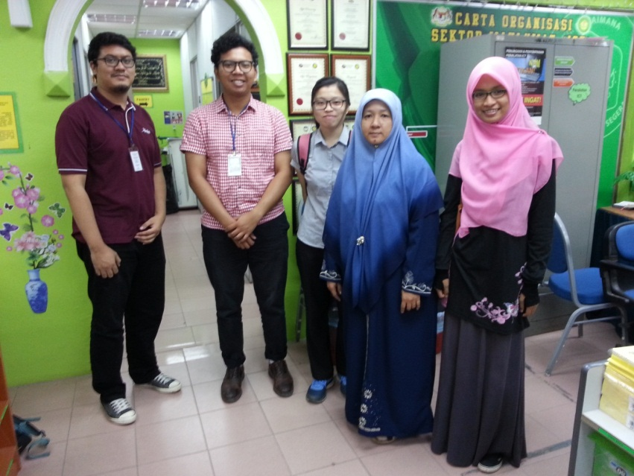

Figure : A photo of Pn Khadijah Ahmad and all the PUS team member

### Interview Question and Answer

The following is the related questions that have been prepared in the interview session with Pn Khadijah Ahmad:

1. How the current system works?

* The current announcement is distributed by using portal. In order to distribute the announcement, administrator needs to get approval before it uploaded through portal as it have been mention in their procedure. In ICT sector. It has 3 technician and 3 staff that handle the information to be distributed through portal. The host is from Kementerian Pendidikan Malaysia(KPM) where the portal is handle by Jabatan Pendidikan Negeri. Pejabat Pendidikan Daerah(PPD) handle the schools that under their supervision. So, any information or announcement about school is uploaded through PPD’s portal.

1. What is problem that they face when distributing announcement?

* The problem is school authorities need to access PPD’s portal every day in order to get any latest announcement from PPD.
* The other problem is when the announcement involving parents where we know that parents does not access the portal every day.

1. In your opinion, are the system we plan to develop is giving a benefit to parents or not?

* Actually, that kind of application is already developed named as Sync. But not every school use it. But, when your application provides more function than the current application, it can give benefit not only for parents, but also for school.